Abhisek Gautam

13679042

36104- Data Visualization and Narratives

Visual Analysis of Olympics Data

# Introduction

Olympic Games is a well-known sporting platform which is recognized all over the world, has been distinguished from the late 19th century. Its origin however can be traced back to the Greek empire, at around 3,000 years ago, which consisted only of sprint race, and was held in Greece’s city Olympia only accessible to freeborn Greek people (Young & Abraham, 2020). It has grown since then and now has become a hub for all the athletes worldwide to demonstrate their abilities in more than 28 individual sporting contests. Currently, it is held every 2 years in different countries, with names Summer Olympics and Winter Olympics, both having their own set of games (Young & Abraham, 2020). It has become a place which reflects the power of the individual contestants and has become a source of pride for the countries they represent.

# Motivation and Research Questions

Olympics has a rich history, spanning from 1896 till 2018, and has been a part of history. So, it is an interesting topic to see how the historical events have affected the specifics of Olympics and how it has been changing till date. Hence, this report attempts to build around the following questions, with some connection to historical happenings where suitable:

1. What effect does the host country have in the medals won at the Olympics?
2. Is the performance of countries in Olympic games affected by the economic factors of the country?
3. Is the age of winning Olympics changing?

# Literature Review

The advantage of host country in any sporting activity is well known, as the participants will have familiarity of the field, and also there is a great support from the home crowd. Host countries are expected to win 3 times the medals that they were winning while playing as away (Clarke, 2000). Being a host nation and also having a communist background is also going to have a positive effect in the number of medals won (Bian, 2005).

It is found that a country’s socio-economic variables, such as GDP affects the country’s performance in the Olympics by a great factor. Country’s population and its GDP is seen to have a correlation with the number of medals won in Olympics (Bian, 2005).

Age factor is also one of the important ones when it comes to sports and even among the athletes of the same age, relative age effect (RAE) comes into factor which determines who triumphs (Fletcher & Sarkar, 2012). RAE states that an athlete can have more advantage as compared to another who is younger by almost a year with respect to maturity, experience and early specialization (Neill, Cotton, Cuadros & Connor, 2016).

Olympics has been a part of the history, and has affected, and also has been affected by the history. Olympic Games has made major social and political impacts throughout the history like including women in sports, has taken a stand against racial matters, promoted civil rights, has unified countries and even has been a tool to demonstrate power by different countries (O’Connell). Similarly, the politics of the countries such as racial separation, terrorism, World Wars and the Cold War have also affected Olympics at different times in the history (Dwyer & McMaster, 2018).

# Approach

To answer the questions, three datasets were used namely, “120 years of Olympic history: athletes and results[1]”, “Gapminder GDP per capita, constant PPP dollars- v25[2]” and “Gapminder Total Population v6[3]”. The Olympics dataset had the names of participants, their demographics, which sport they participated in and on which Olympic games. Gapminder’s GDP per capita dataset consisted of GDP of countries from 1960 forecasted till 2040, and their Population dataset had populations of all the countries of the world from 1800 till 2019 and forecasted from there onwards till 2100. A custom dataset was also created that maps the cities mentioned in the Olympics dataset to country names.

Visualizations were created in Tableau and Python. Initial data cleaning was done on Excel, and visualization specific data manipulation were carried out as needed on Tableau and Python.

# Findings and Discussion

## Host Country Effect

Figure 1 shows the number of times a country has hosted Olympics. The USA has hosted it the most, i.e. 8 times followed by France, which had hosted it 5 times.

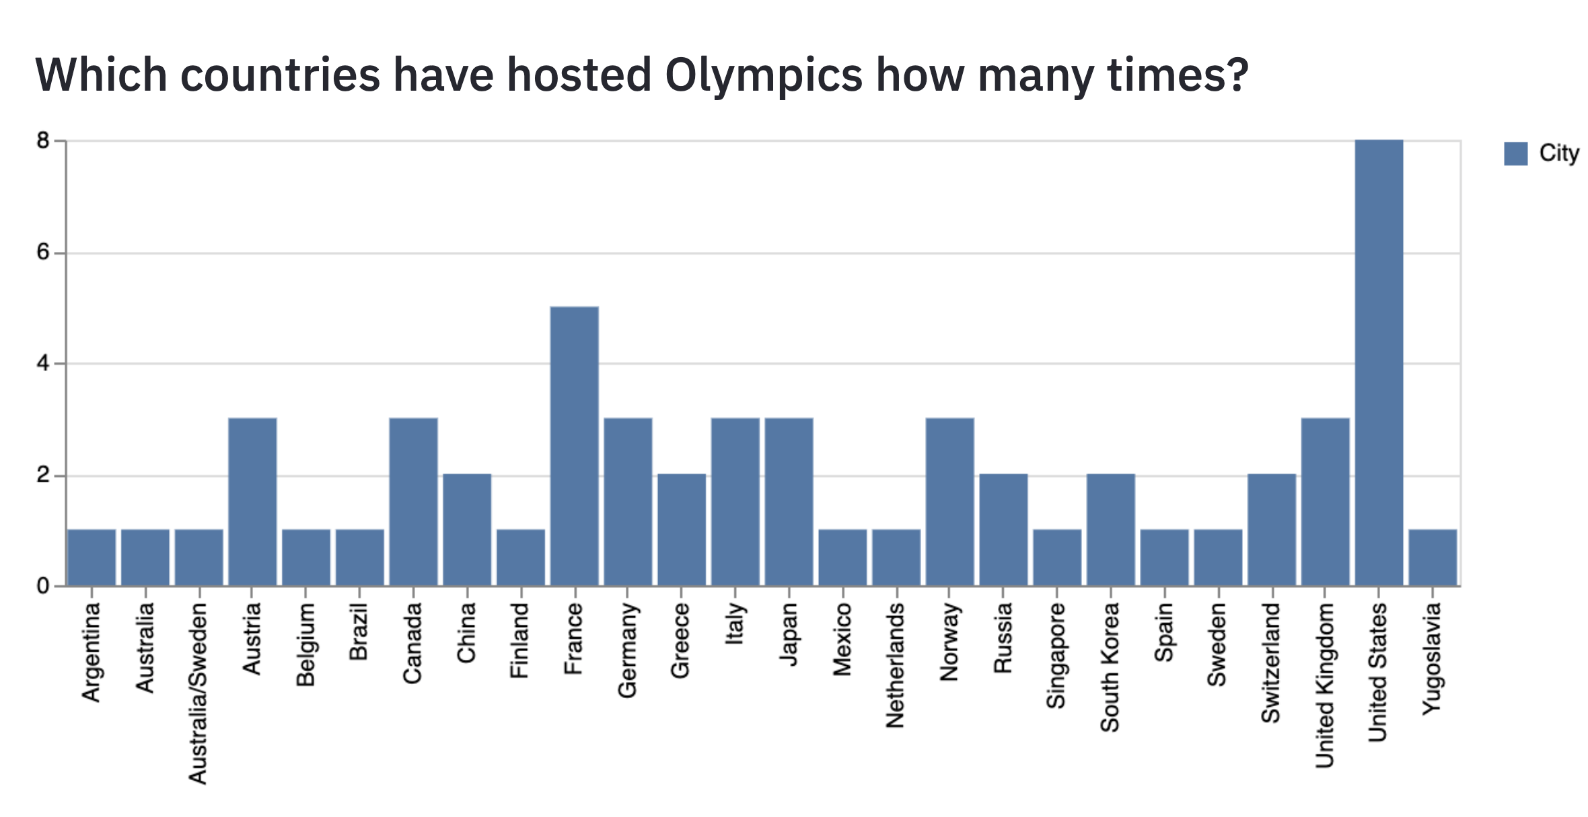

Figure - Countries that have hosted Olympics

Figure 2 shows the total medal winnings of countries that hosted Olympics, and shows that USA has won the most medals, and then it is Germany, followed by France. This hints that the countries which have hosted more Olympics have won more medals. The reasons why the host countries win more medals are due to home field advantage, crowd support and easier qualification criteria, hence more participation (Clarke, 2000).

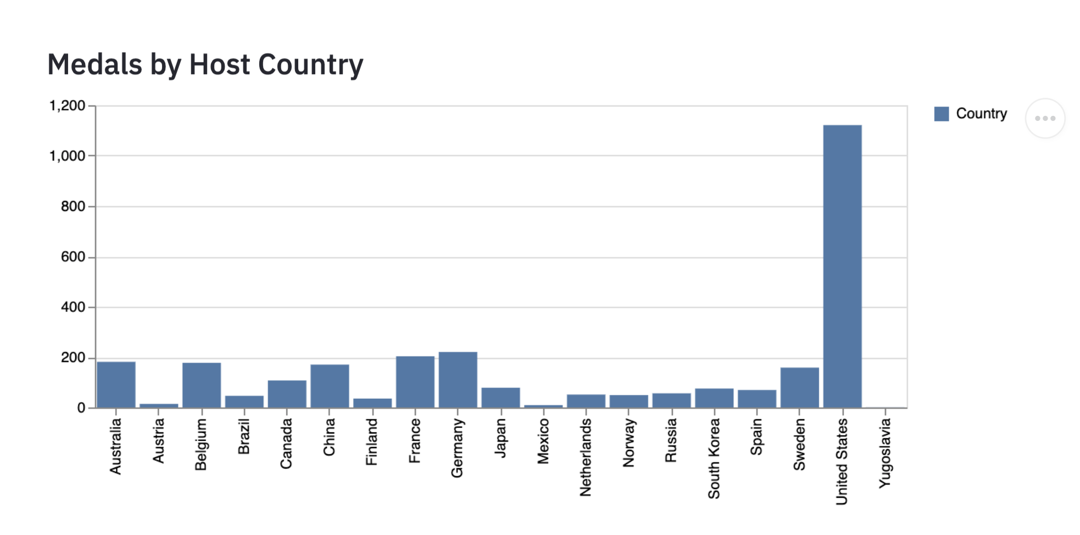

Figure - Medals won by Host Countries

Now let us see how the number of won medals vary with regards to the host country. Firstly, looking at the USA’s medals won (Figure 3-4), we can see that the number of medals won by it has always increased when it hosted the Olympics. Note the sharp increase in the graph from 1976 till 1984. USA had protested against Russia’s invasion of Afghanistan by boycotting the 1980’s Olympics held in Russia, so the data of that year is not available. And immediately in 1984, Russia boycotted 1984’s Olympics which was held in the USA, thus the USA won more medals.

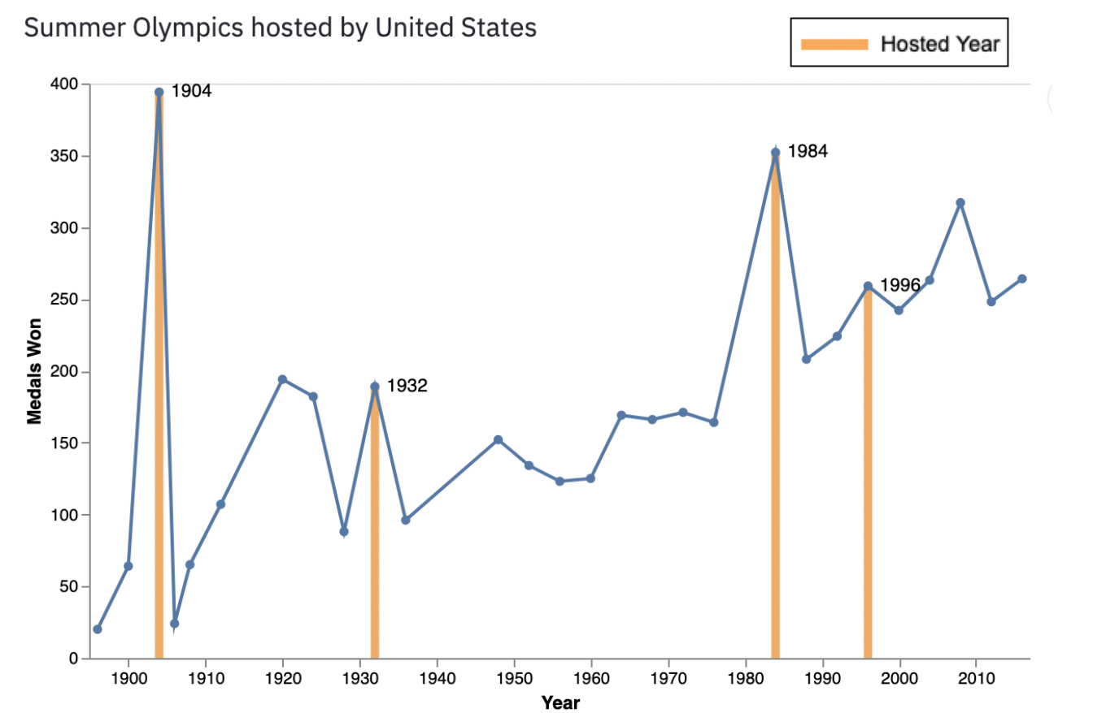

Figure - Summer Olympics medal counts of the USA

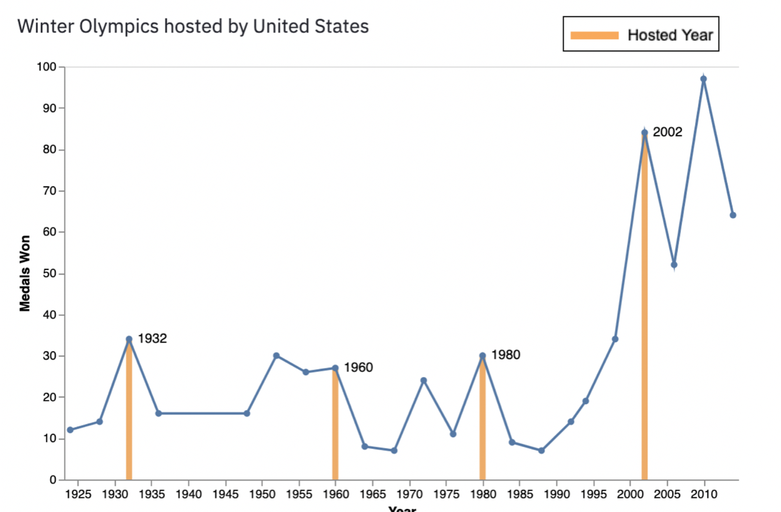

Figure - Winter Olympics medal counts of the USA

In some cases, the host country prevails in successive Olympics after they host, such as Spain (Figure 5), which had a tremendous increase in medal count when they hosted the Summer Olympics in 1992 (from 5 to 69) and have won more medals in the following years.

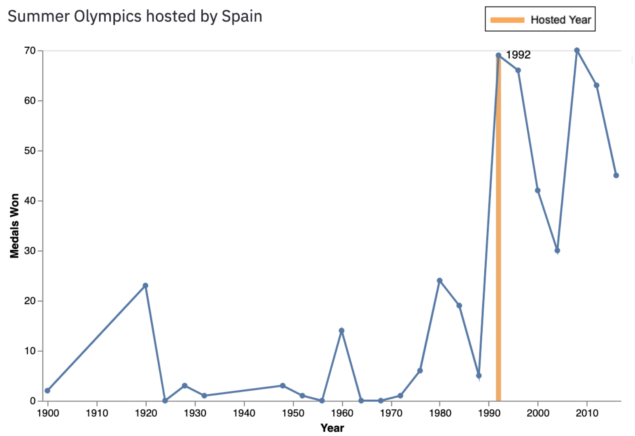

Figure - Summer Olympics medal counts of Spain

A similar trend is shown by other countries such as Japan (1964), South Korea (1998), Mexico (1968) and Norway (1994) where they have increased their medal counts in average after holding the Olympic games. However, countries such as Finland (1952), Canada (1976) and Russia (1980), though they won more medals when hosting, were not able to increase their medals in the successive years (Refer to Appendix I).

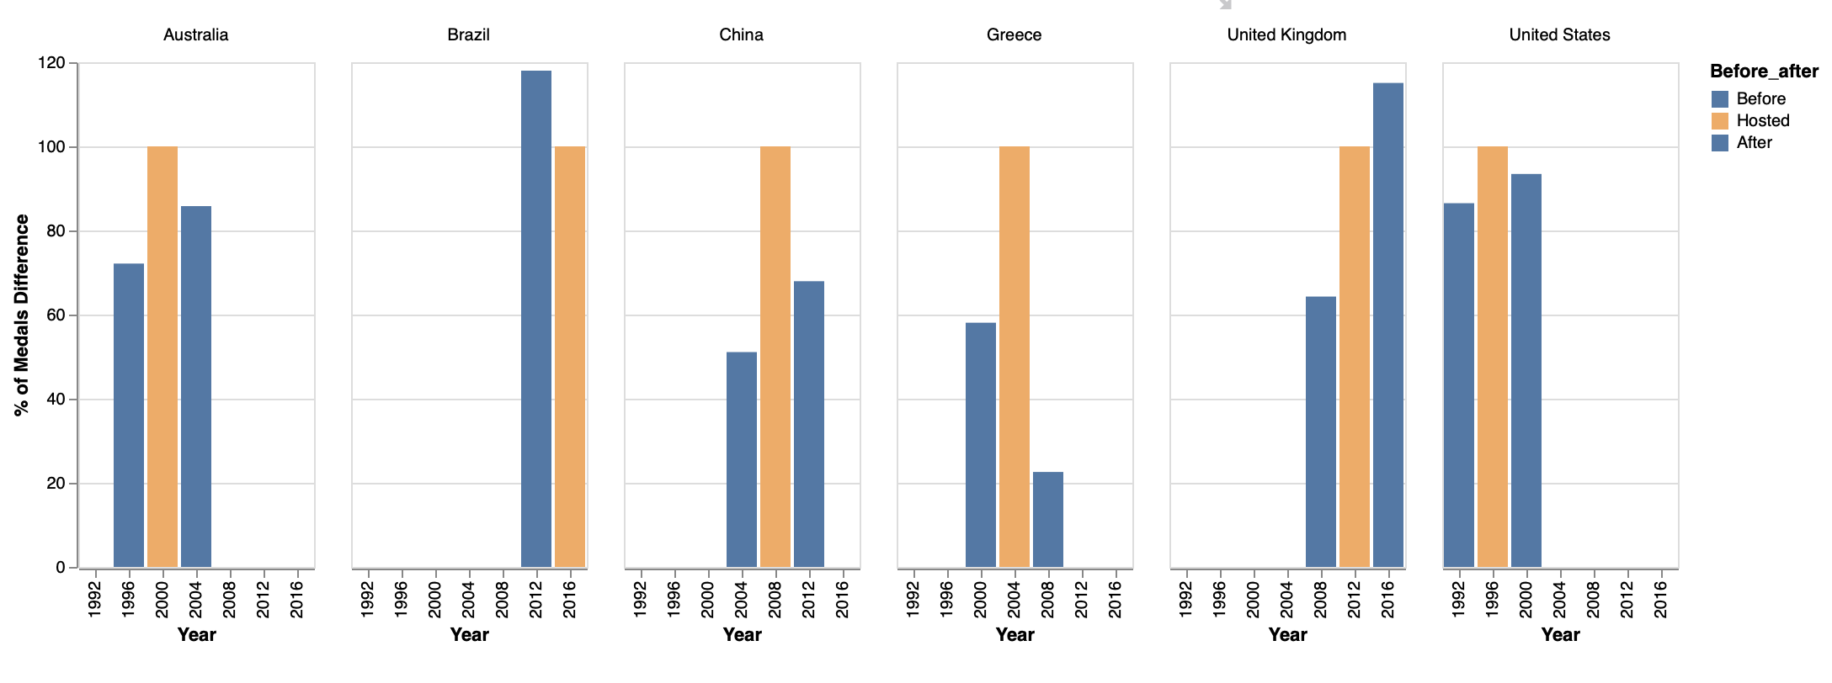

Figure - Percentage of winnings before, when hosting and after in Olympics, (100% when hosted)

Countries such as Australia (2000), China (2008) and Greece (2004) United Kingdom (2012) and United States (1996), have won between 10-20 % more medals when they were the hosts (Figure 6). Its only Brazil (2016) which failed to score more when they had hosted it (20 per cent less than when UK Olympics in 2012), whereas Greece managed to bag only 20 percent medals in 2008 after the Greece Olympics.

## Economic Effect

The most basic and important economic predictors, the Gross Domestic Product (GDP) can be used to evaluate the performance of a country in the Olympics (Bernard & Busse, 2000). One of the derivatives of the GDP is the GDP per capita, which gives the earning of an individual person in the country can also be looked into. The GDP and GDP per capita are plotted in Figures 7-8 to see how they relate to the winnings. The graph is observed to be more scattered in the plot with GDP per capita (Figure 7), with correlation coefficient only 0.1, whereas that for total GDP was 0.17 (Figure 8), meaning that for the 2004 Olympics (and other Olympics- Appendix II), the number of medals won is a factor of GDP.

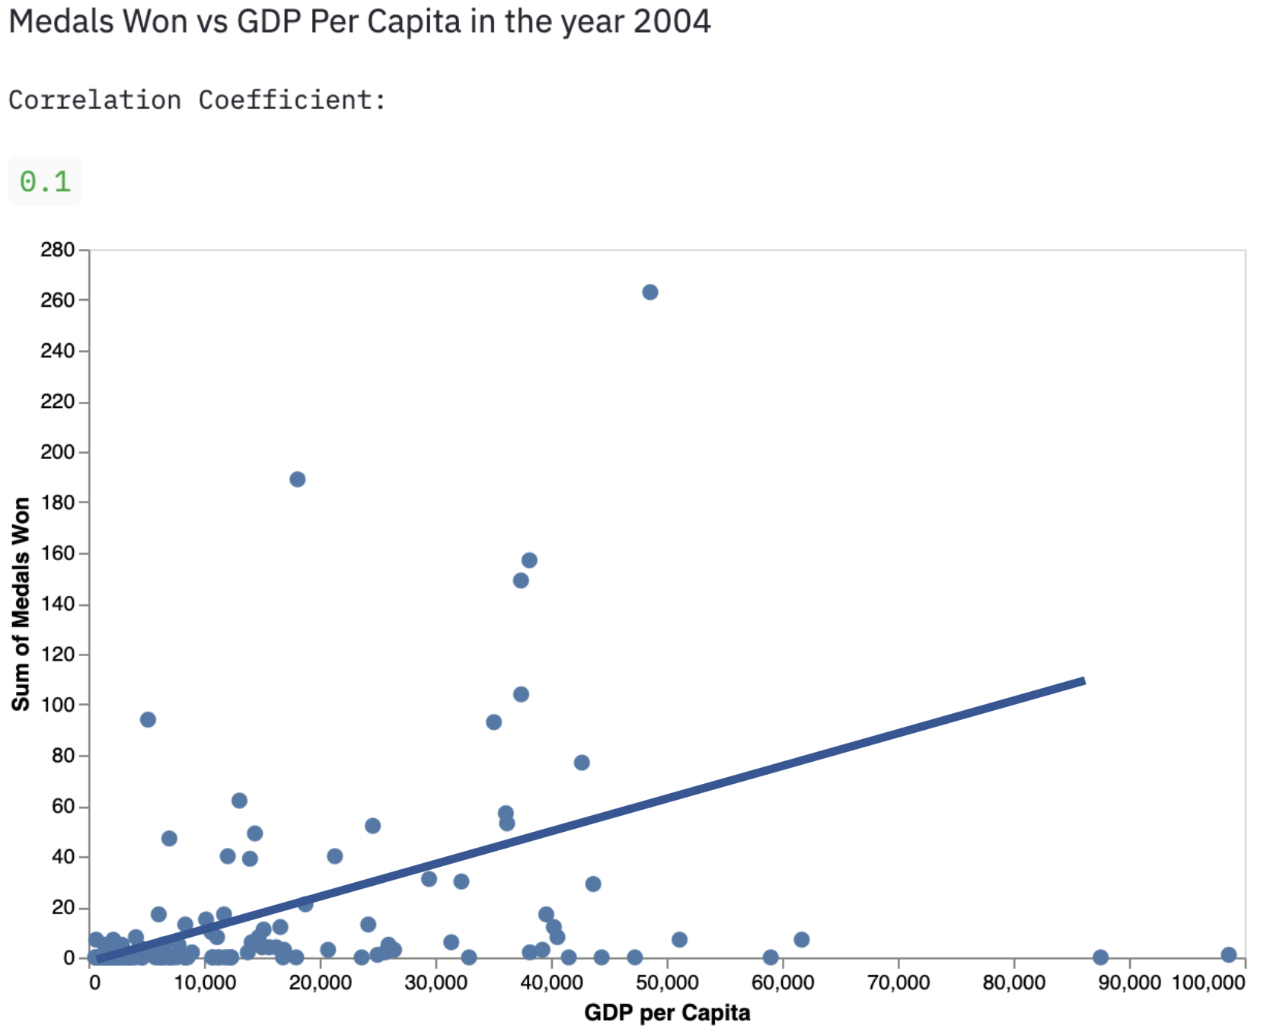

Figure - Medals Won vs GDP Per Capita in 2004 Olympics

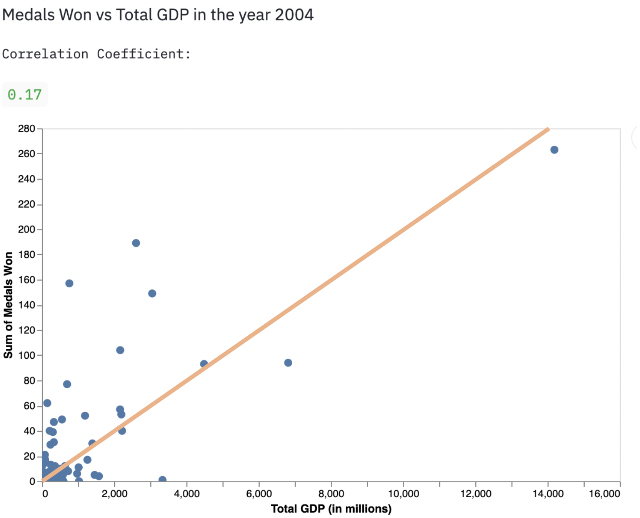

Figure - Medals Won vs Total GDP in 2004 Olympics

Analysing the correlations of total population along with GDP and total GDP to see how they relate to the medal counts (Figure 9), the GDP has always had a better correlation with medals won. This is not surprising because just having a better economy does not guarantee an Olympic medal. It also requires a large population pool from which best participants can be selected, much like selecting from a large sample space.

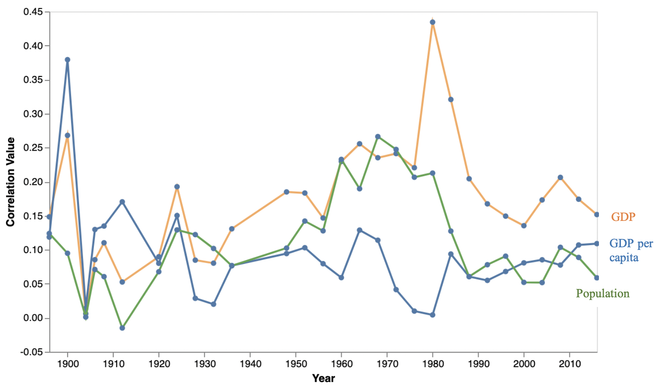

Figure - Correlation of GDP, GDP Per Capita and Population plotted with Year

Figure 9 also shows the correlation values have gone up and down for Population and GDP per capita along the years. The early periods, from 1896 till 1936 show that the country with the most GDP per capita had better chance of winning medals. This may have been due to rich countries only participating in the Olympics. This changed after the World War II until 1988 sand the Population was more correlated to medal count in comparison). In this time, there was Cold War between The Soviet Union and USA, rise of communism (esp. in China), and prevalence of drug use by athletes. Olympics was a good stage for the countries to show their power. Countries which were able to select from a greater population, keep their athletes paid and trained won more medals. The concept of paying Olympic athletes also started at that time. Soon after the downfall of Soviet Union in 1991 and the unification of Germany, the competition to demonstrate power had subsided. So, in the recent years, the role of population and GDP per capita has very less correlation (less than 0.1).

The number of medals won, and total GDP of the China and Tuvalu are shown in Figure 10-11.

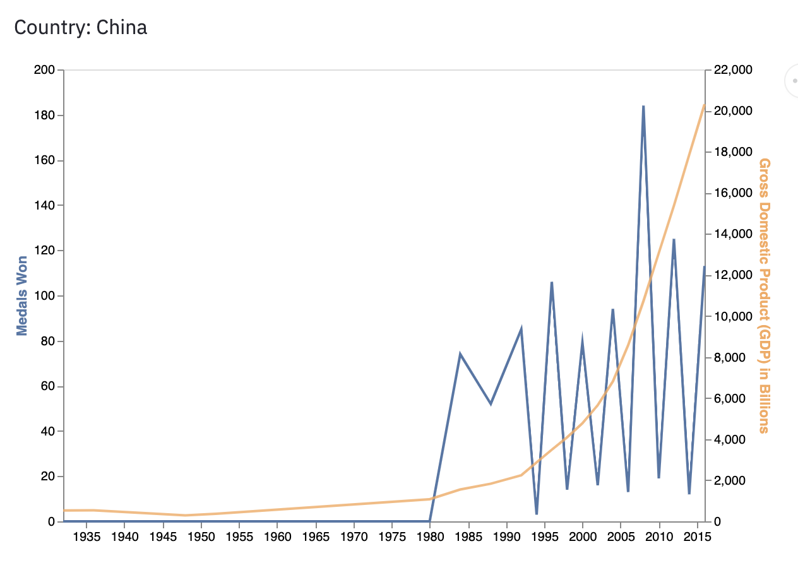

Figure - Medals won by China (highest GDP)

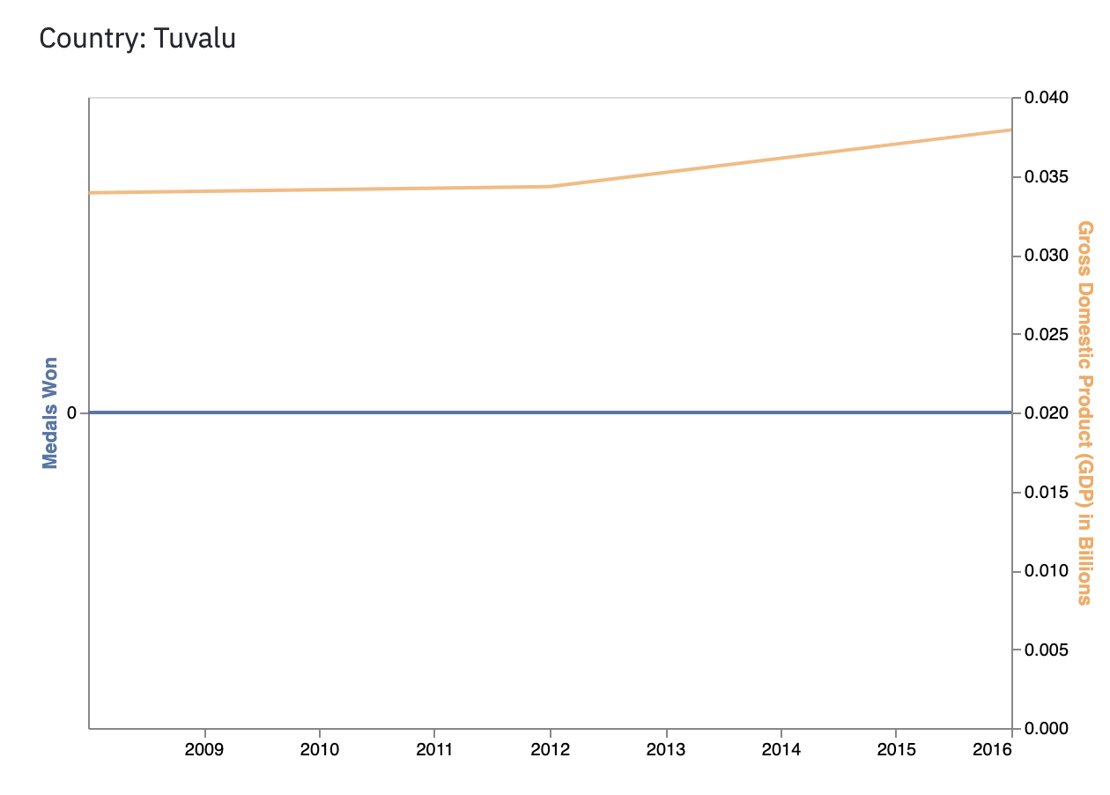

Figure - Medals won by Tuvalu (lowest GDP)

If we look into the top and bottom GDP countries (Appendix II), we see that the countries that had the least GDP have zero medals, whereas the top have all won more than 50 medals, with the highest of 264 by the United States. All these hint that the total medal winnings are related to the total GDP of a country in the Olympics.

## Is the age of winning Olympics changing?

Figure 12 shows the mean age of the medal winners from the start of Olympic Games. The mean age was high during the early 1900s (around 27-28), had some fluctuations till 1948. It decreases to 24-25 there onwards till the 90s, from where it goes up to 26-27 till 2016 Olympics.

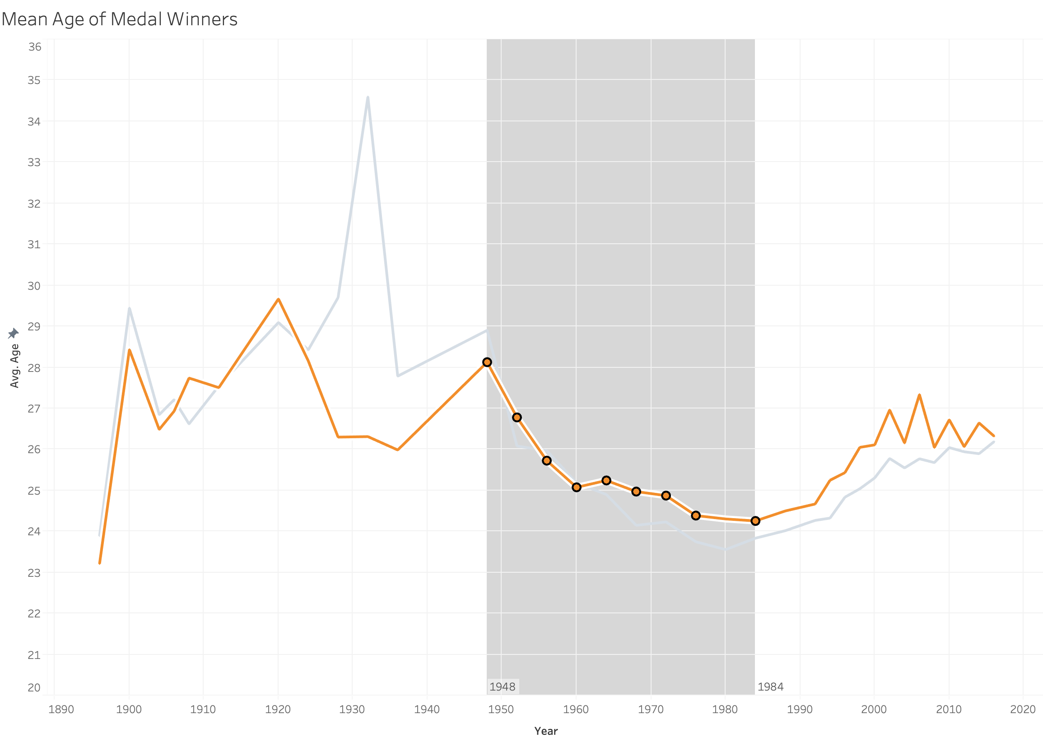

Increasing, and Stable

Decreasing

Unstable

Figure - Mean Age of Medal Winners in Olympics

Now, let us look at how the ages change for the sports that have been continuing since the start of the modern Olympics.

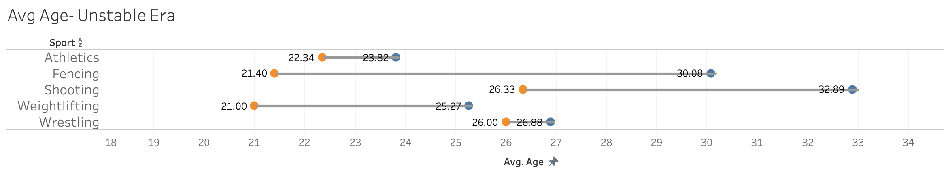

Figure - Age of winners from 1896 till 1948

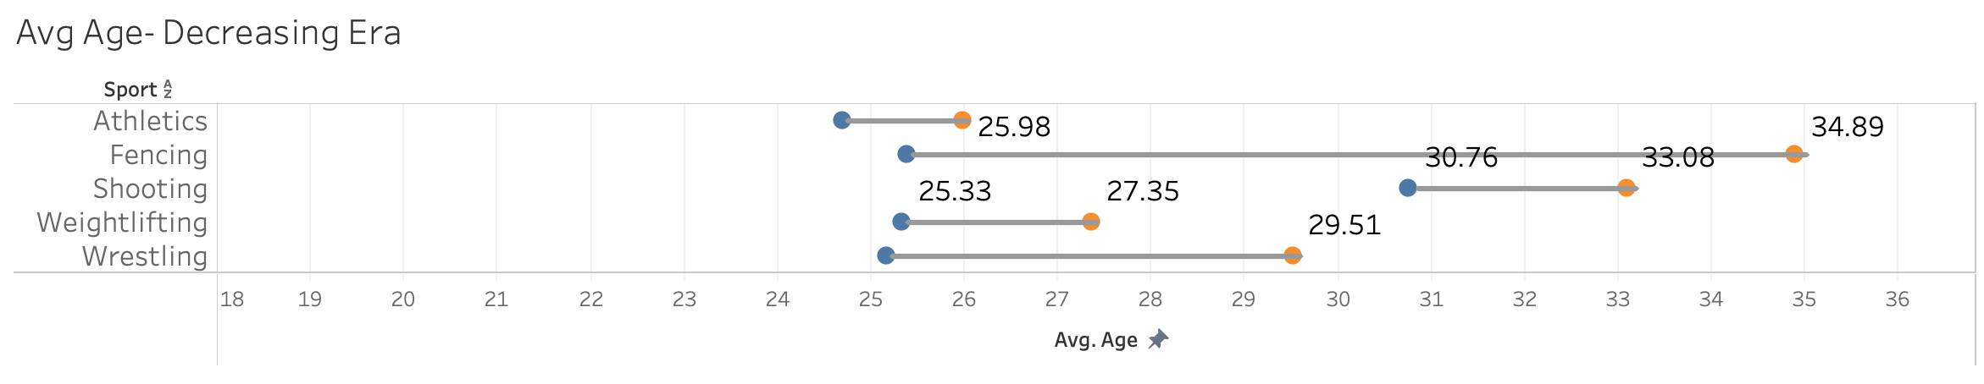

Figure - Age of winners from 1948 till 1984

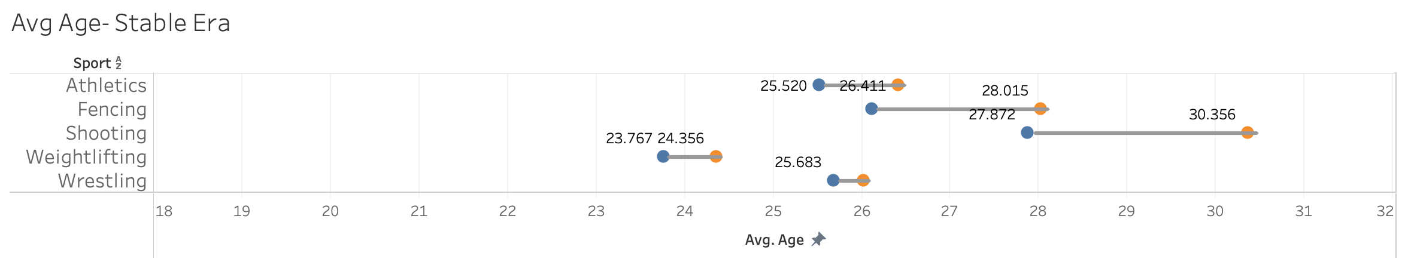

Figure - Age of winners from 1988 till 2016

Figure 13 shows that the age of winners had a big variation during the unstable time period, which decreased a little on the decreasing period (Figure 14), and finally during the modern time (Figure 15), it has become the least. The optimum age to win certain sport is seen to be narrowing down. Appendix III shows the variation for all sports from 1988 till 2016.

# Conclusion

It is clear that the host countries have always a better chance of winning medals in the Olympics; they can win at least 10-20 percent more medals. Looking at the economic effect, even though country’s population and per capita GDP affected the number of medals won in the past, the total GDP of the country is more significant to determine the winnings in the recent years. With the age factor, the age range of players winning medals has decreased over the years, and an optimal age for each sport can be identified in the recent years. Thus, there is a high chance for an athlete from a host country with high GDP, whose age range falls in the optimum age range for the sport to win a medal in the Olympics.

# Recommendations

The study is a high-level analysis of the factors that come into play in the performance in the Olympics. There are many areas where deeper analysis into each of the factor can be made. Some of the questions that may be looked upon can be as follows:

1. **Host Country Effect**- What is the probability that a participant of the host country can win a medal? Are there any type of sports that the host country has more chance of winning?
2. **Economic Effect**- Are there any sports that are won mostly by countries with low GDP? Does the rise/fall in economy affect the Olympic winnings of a country, and if so, in how many years is the effect seen?
3. **Age Effect**- Does the Relative Age Effect influence Olympic winnings? At what age is optimum age for each sport? How does the performance of each athlete improve/degrade over time?

Moreover, looking at the medals count in Olympics official site[4] and comparing with the Olympics history dataset used in this report, there are discrepancies, hence the dataset needs to be revised.

# References

Mahtani, K.R., Protheroe, J., Slight, S.P., Demarzo, M.M.P., Blakeman, T., Barton, C. A., Brijnath, B., Roberts, N. (2012). *Can the London 2012 Olympics ‘inspire a generation’ to do more physical or sporting activities? An overview of systematic reviews.* Retrieved from https://bmjopen.bmj.com/content/3/1/e002058.full

Clarke, S. R. (2000, June). Home advantage in the Olympic Games*. In Proceedings of the 5th Australian Conference on Mathematics and Computers in Sport. University of Technology Sydney, Australia*(pp. 76-85). Retrieved from https://researchbank.swinburne.edu.au/file/3bbcf005-ec1e-4def-9602-f7dd18d0a711/1/PDF%20%28Published%20version%29.pdf

Fletcher, D., & Sarkar, M. (2012). A grounded theory of psychological resilience in Olympic champions. *Psychology of sport and exercise,* 13(5), 669-678. Retrieved from

https://www.sciencedirect.com/science/article/abs/pii/S1469029212000544

Bian, X. (2005). Predicting Olympic medal counts: The effects of economic development on Olympic performance. *The park place economist,* 13(1), 37-44*.* Retrieved from https://www.researchgate.net/profile/Xun_Bian/publication/28328103_Predicting_Olympic_Medal_Counts_the_Effects_of_Economic_Development_on_Olympic_Performance/links/5525b9850cf24b822b4058f9/Predicting-Olympic-Medal-Counts-the-Effects-of-Economic-Development-on-Olympic-Performance.pdf

O’Connel, C. *13 Olympic Moments that Changed History.* Retrieved from https://www.rd.com/culture/13-olympic-moments-that-changed-history/

Dwyer, B. B., & McMaster, A. (2018). *18 Times Politics Trumped Sport in Olympic Games’ History.* Retrieved from https://www.globalcitizen.org/en/content/history-political-activism-olympics-rio/

Bernard, A. B., & Busse, M. R. (2000). *Who wins the Olympic Games: Economic development and medal totals* (No. w7998). National Bureau of Economic Research. Retrieved from https://www.nber.org/papers/w7998.pdf

O’Neill, K. S., Cotton, W. G., Cuadros, J. P., & O'Connor, D. (2016). An investigation of the relative age effect amongst Olympic athletes. *Talent Development & Excellence*, 8(1), 27-39. Retrieved from https://www.researchgate.net/profile/Juan_Cuadros2/publication/317582562_An_Investigation_of_the_Relative_Age_Effect_amongst_Olympic_Athletes/links/5cb4a254299bf12097682856/An-Investigation-of-the-Relative-Age-Effect-amongst-Olympic-Athletes.pdf

Young, D. C., Abrahams, H. M. (2020). *Olympic Games*. Retrieved from https://www.britannica.com/sports/Olympic-Games

*Olympic Sports - How Does Peak Age Vary?*. Retrieved from https://www.thestatszone.com/archive/olympic-sports-how-does-peak-age-vary-13812

James, L. *Does money buy medals? Analyzing the affect of GDP on Olympic success.* Retrieved from https://www.yellowfinbi.com/blog/2012/08/yfcommunitynews-does-money-buy-medals-analyzing-the-affect-of-gdp-on-olympic-success-117473

Toshkov, D. (2016). *Olympic medals, economic power and population size*. Retrieved from http://re-design.dimiter.eu/?p=868

# Appendix I- Olympic Performance of different hosting countries

Note- the Orange line indicates the Hosted year for all graphs.



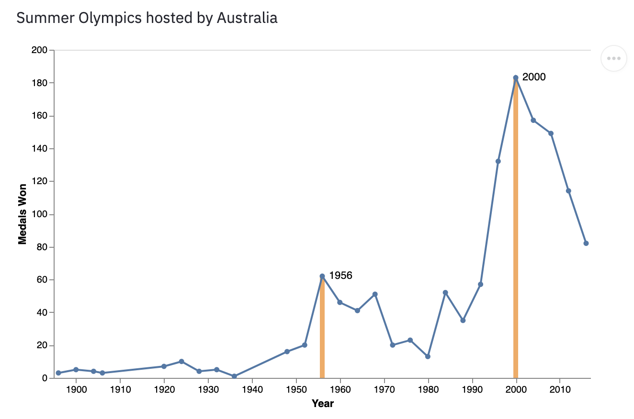

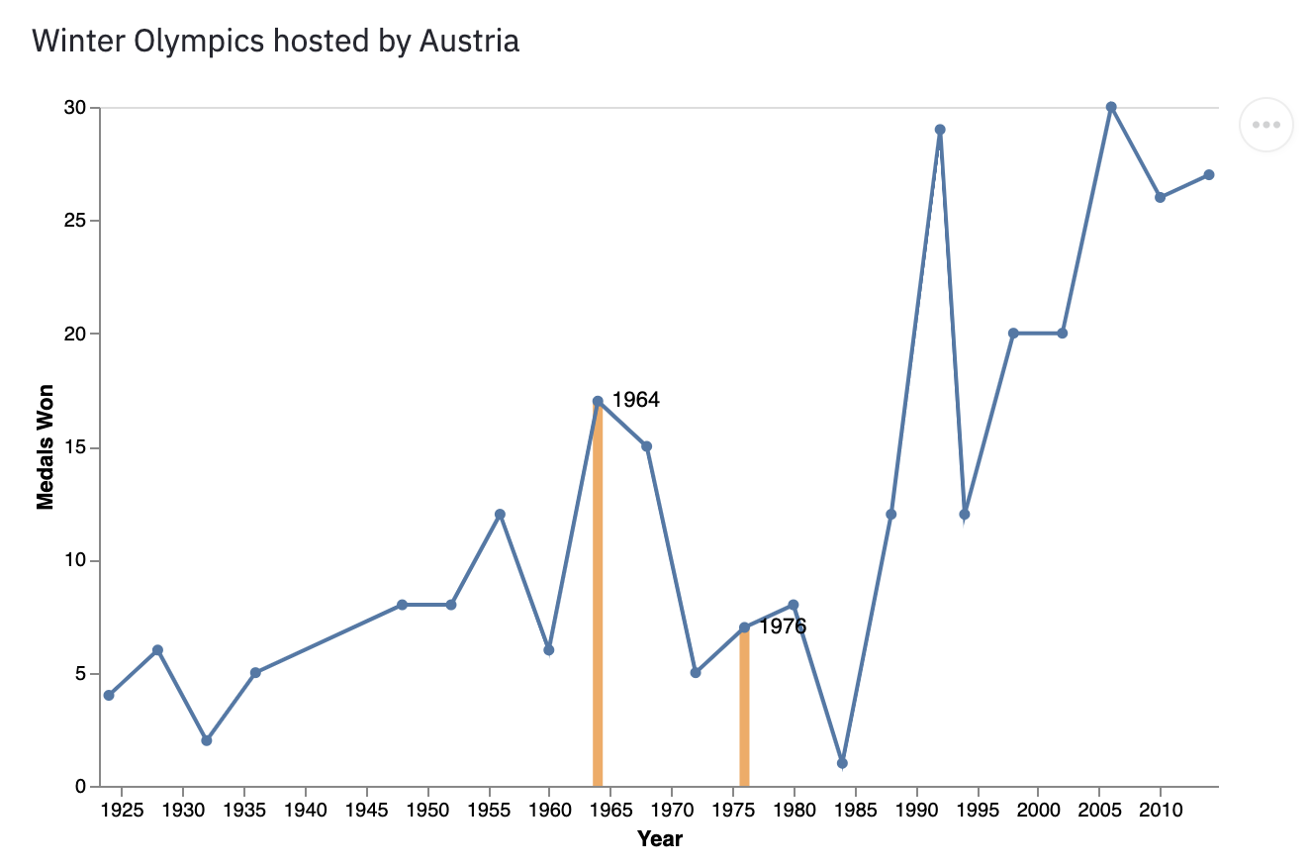

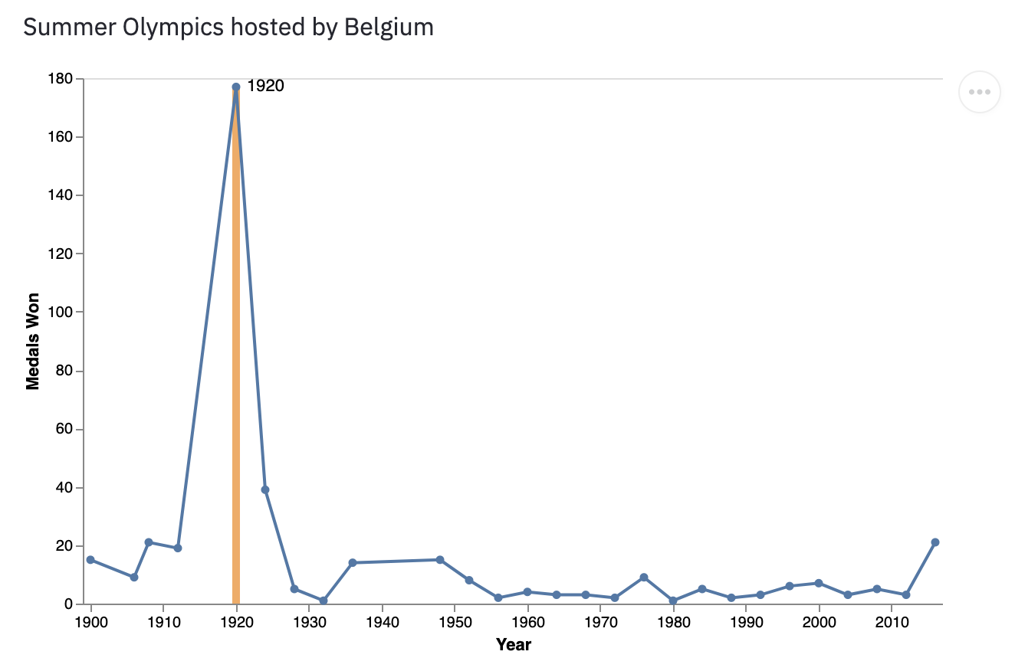

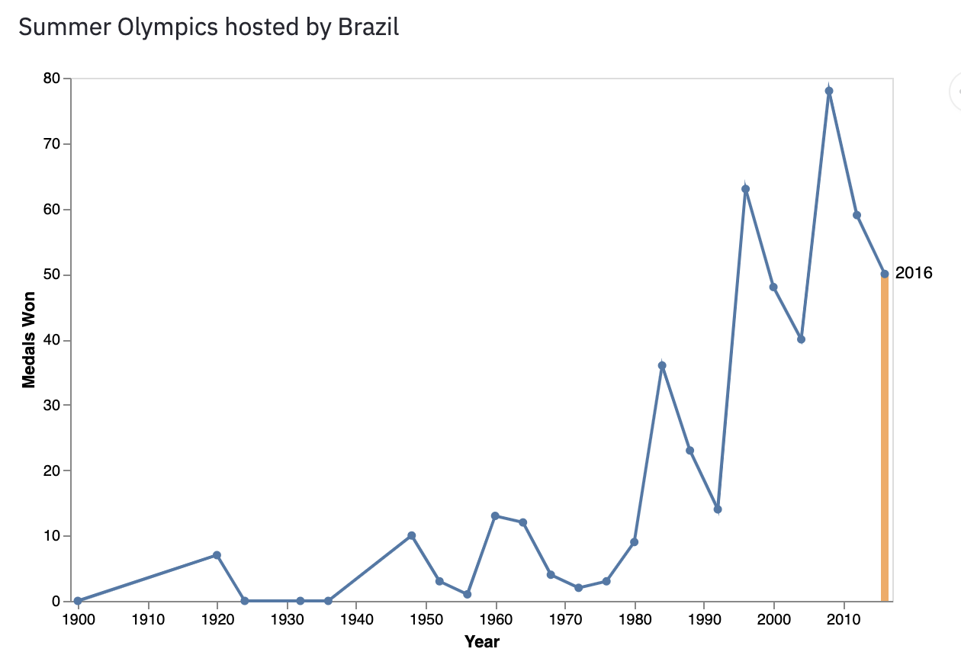

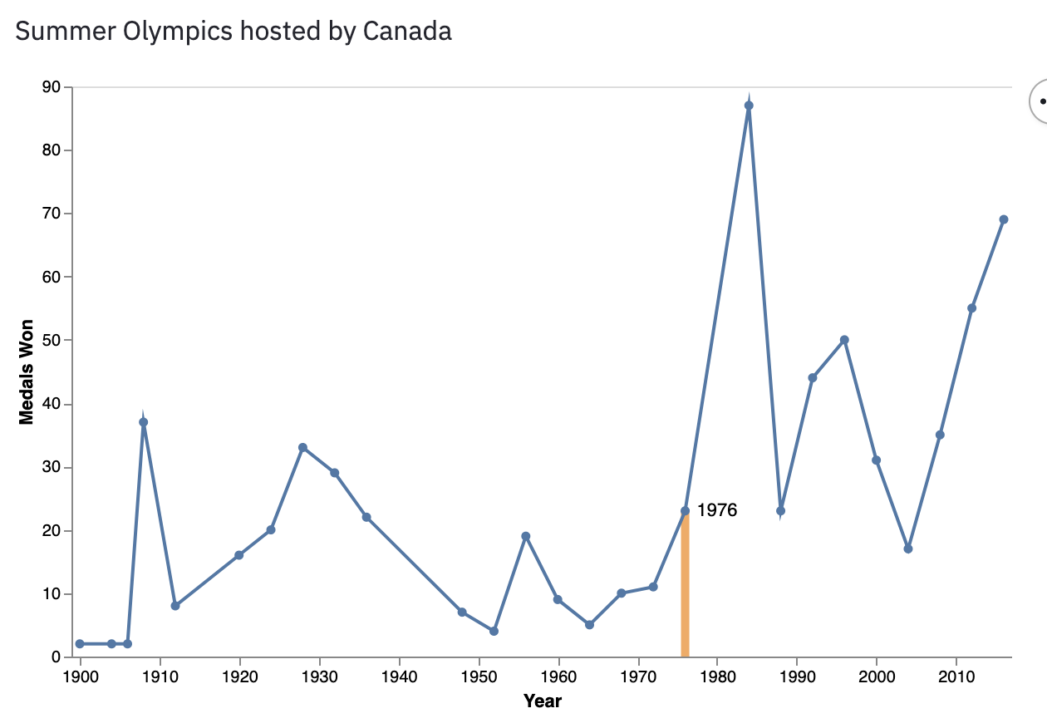

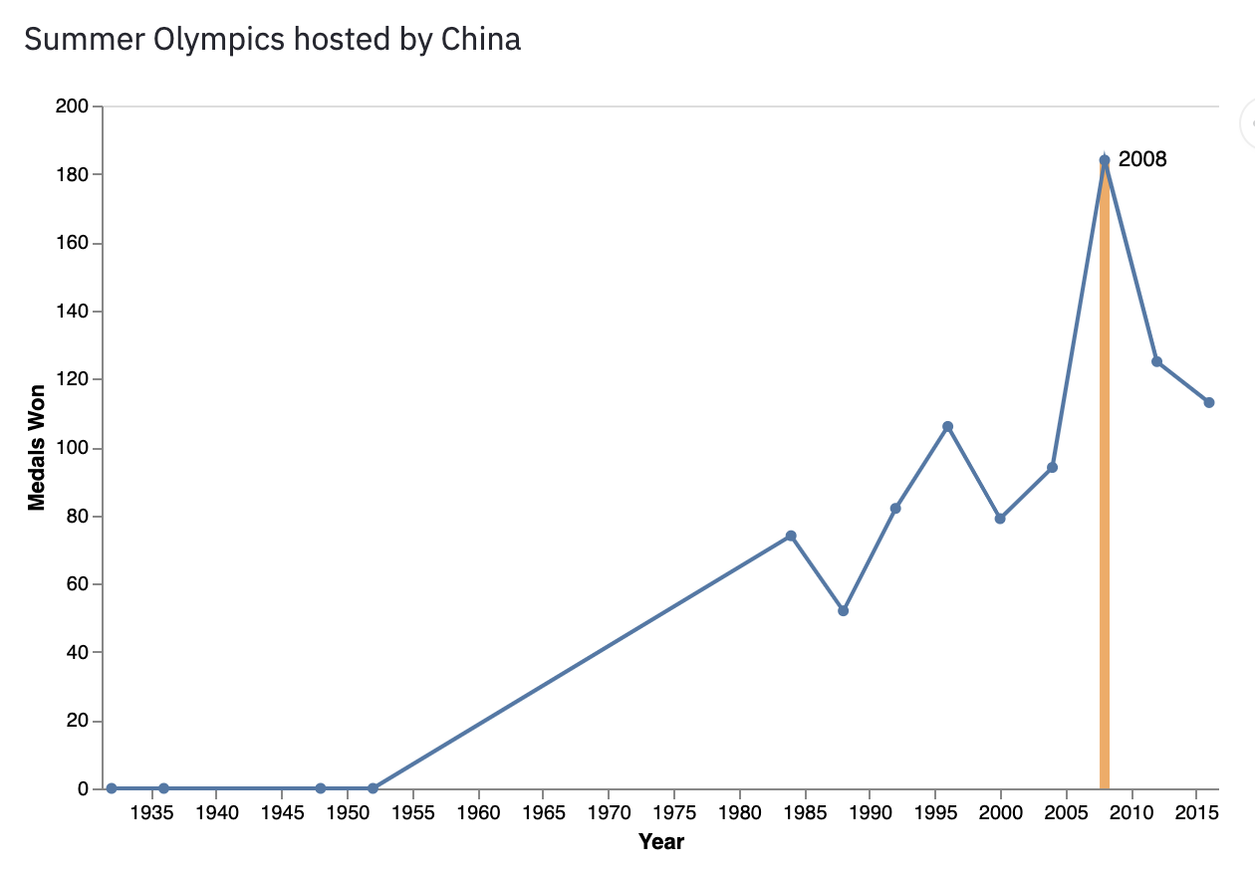

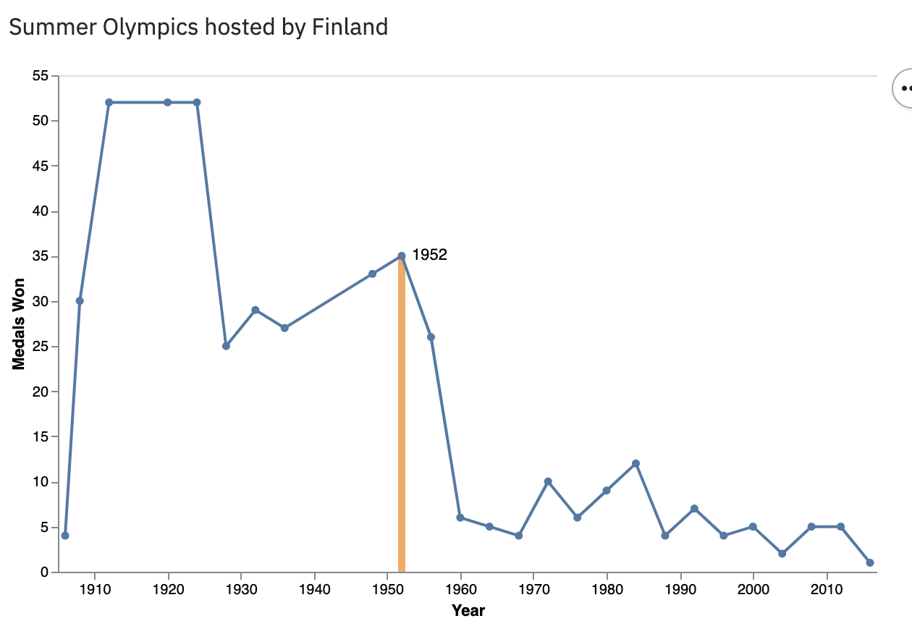

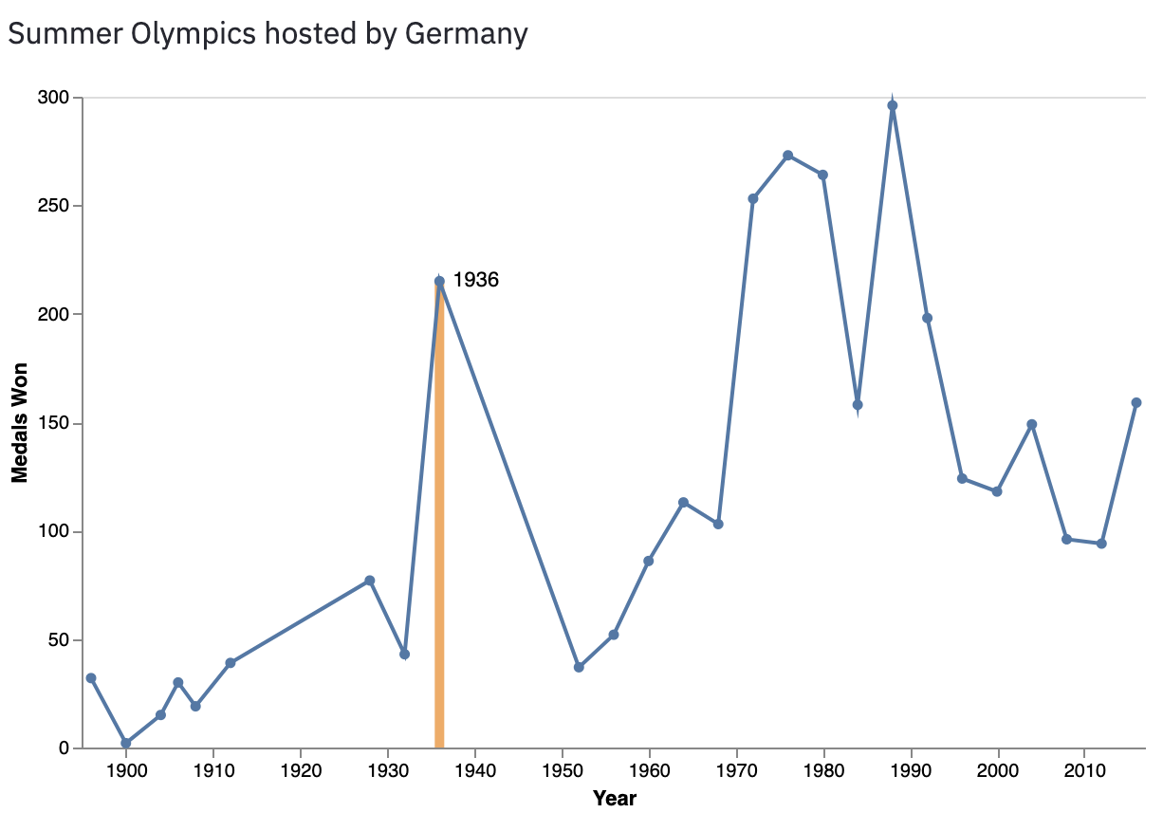

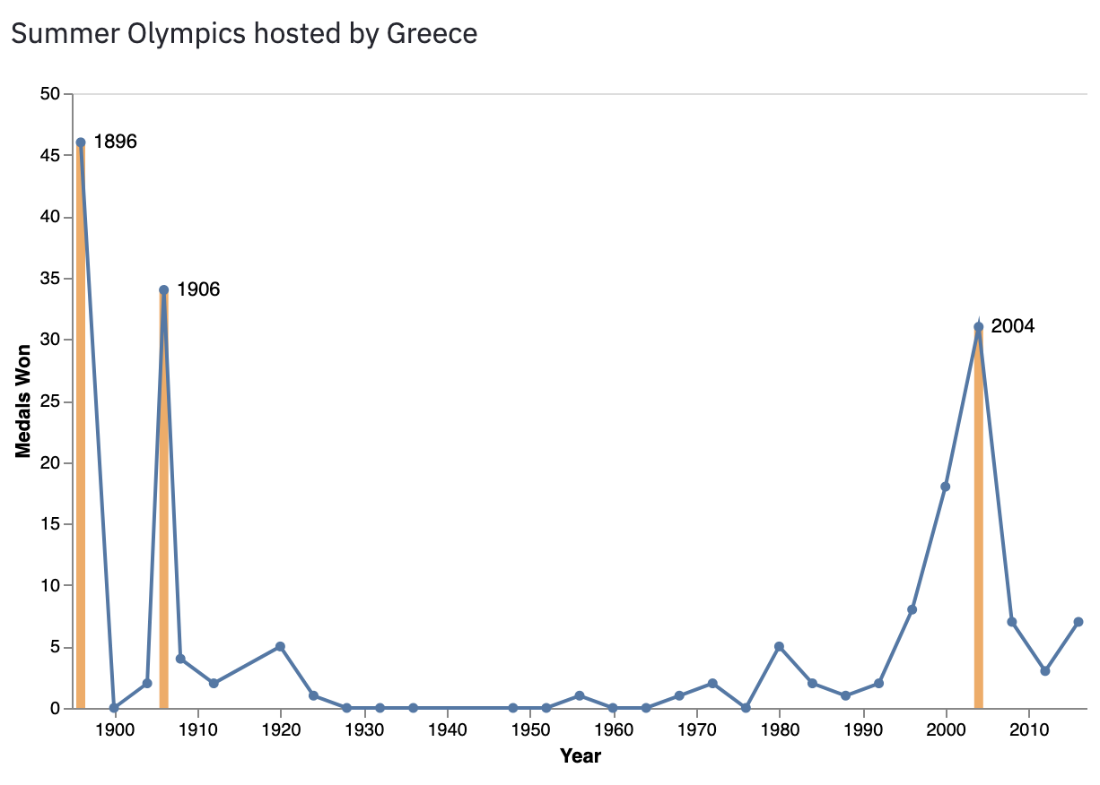

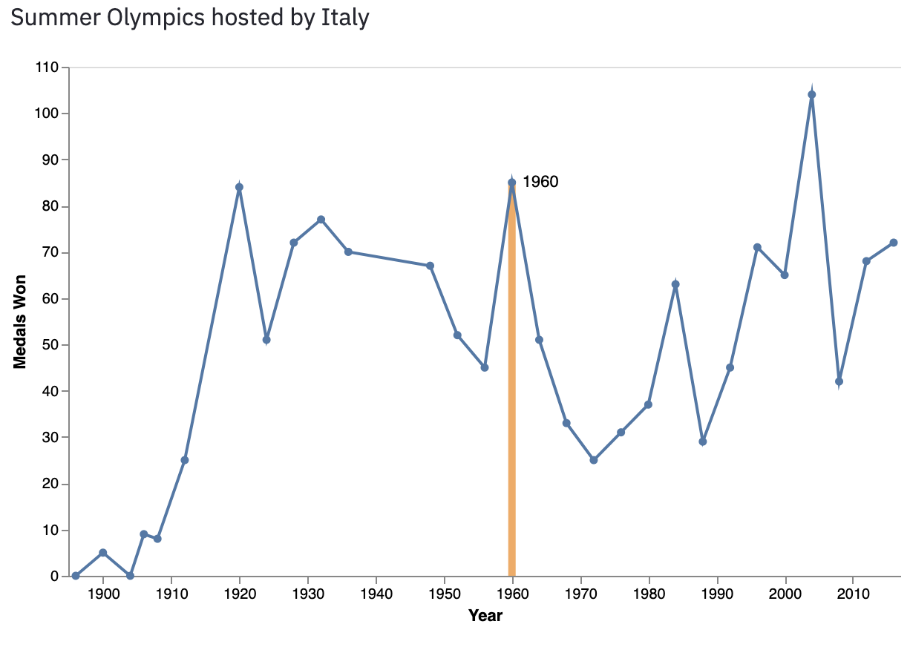

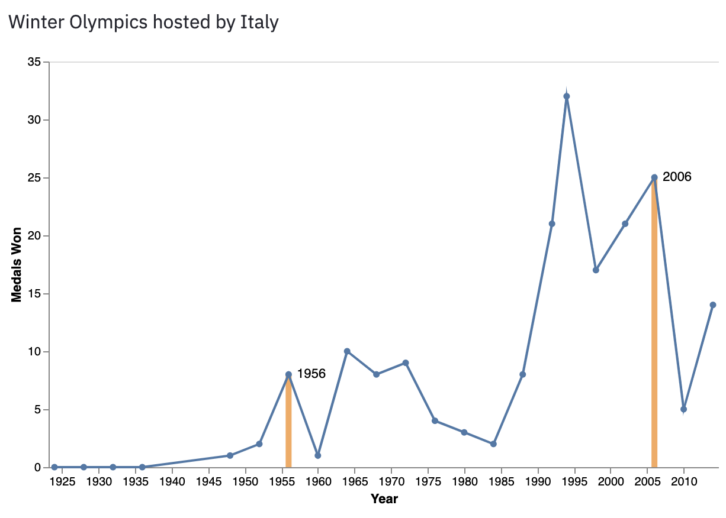

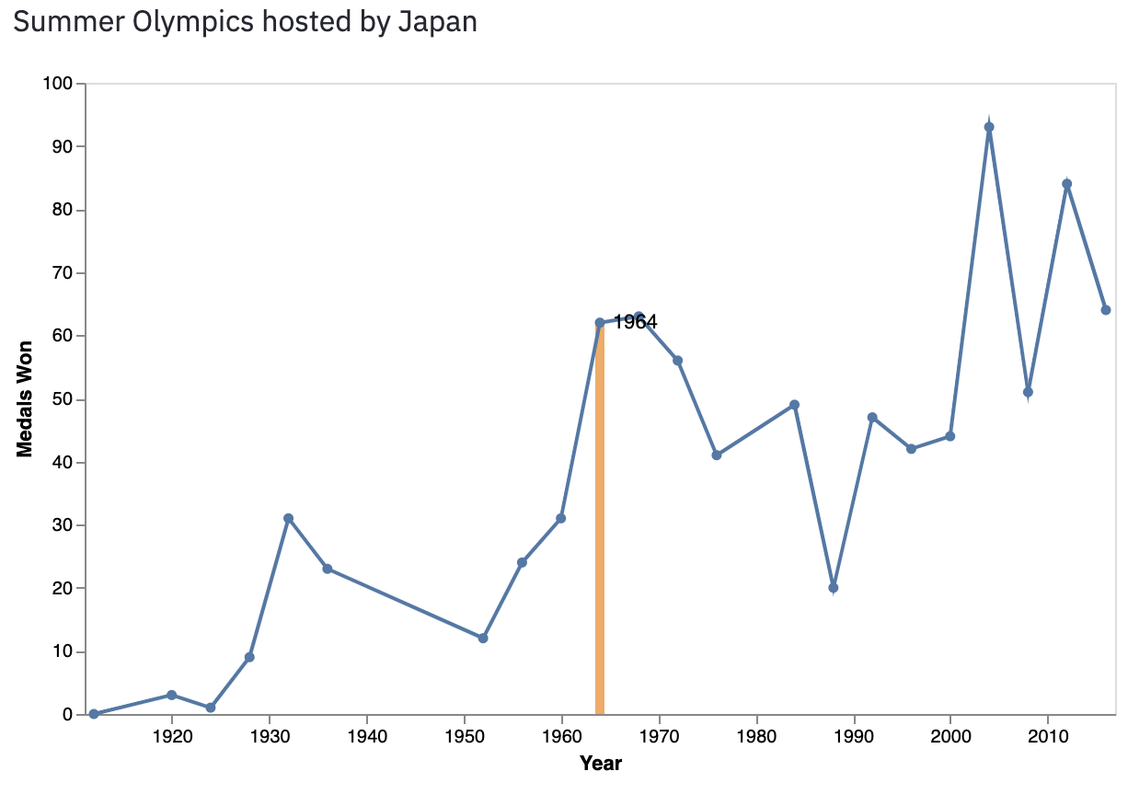

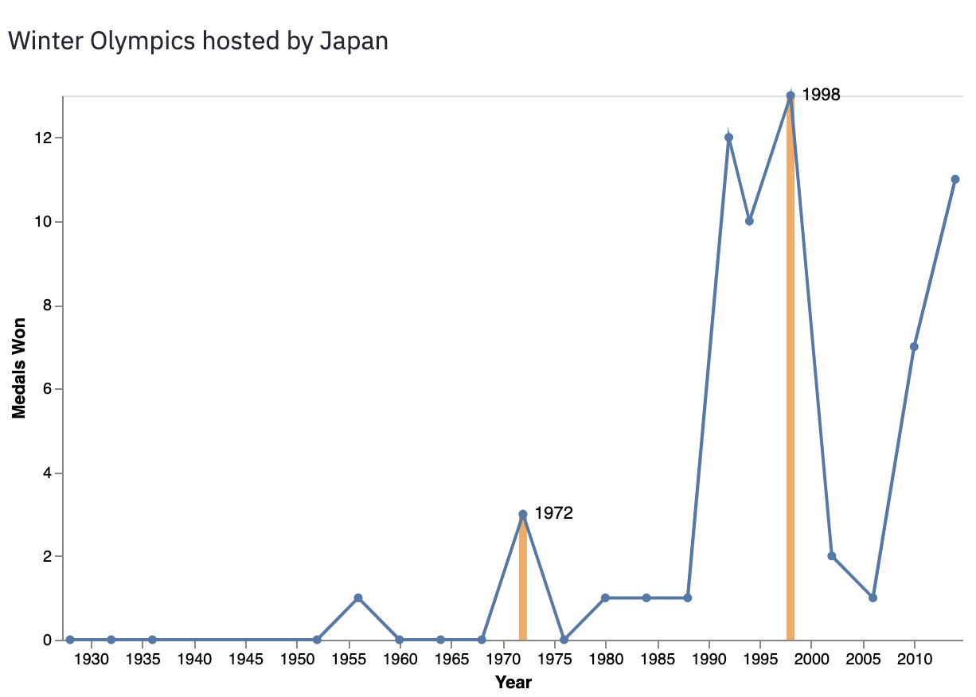

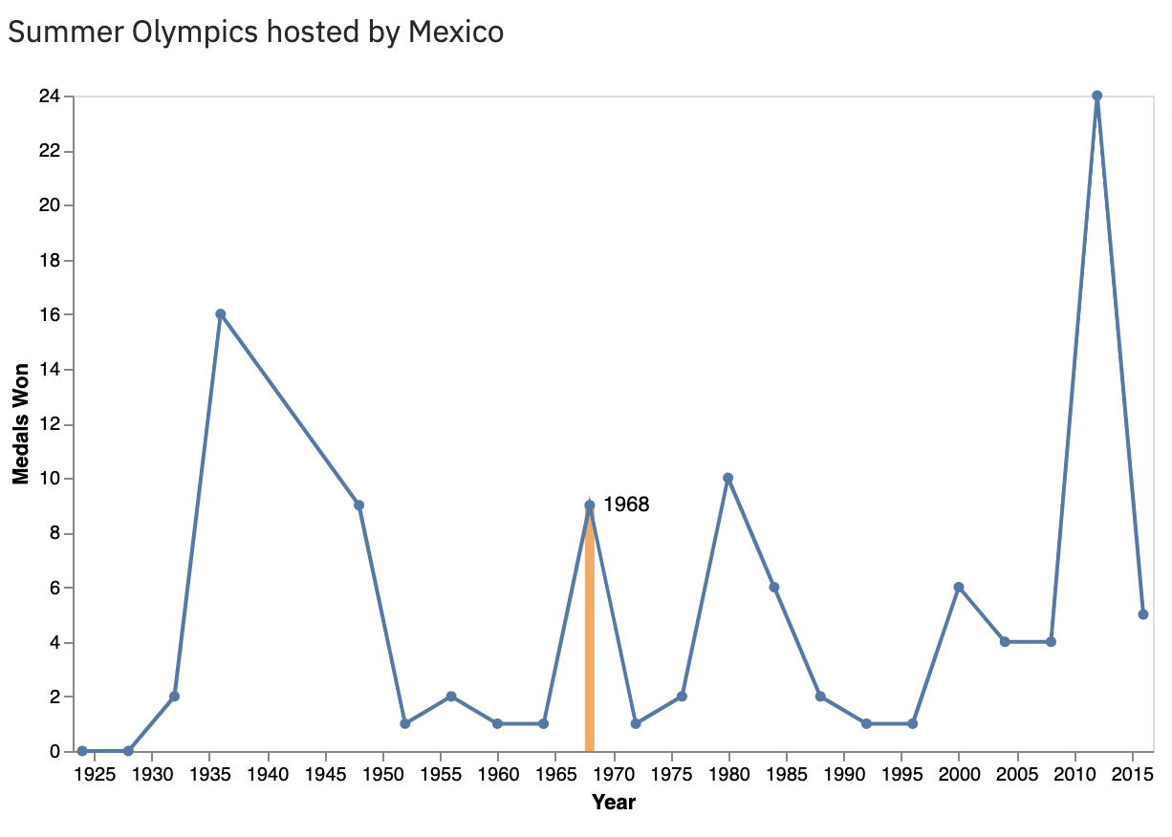

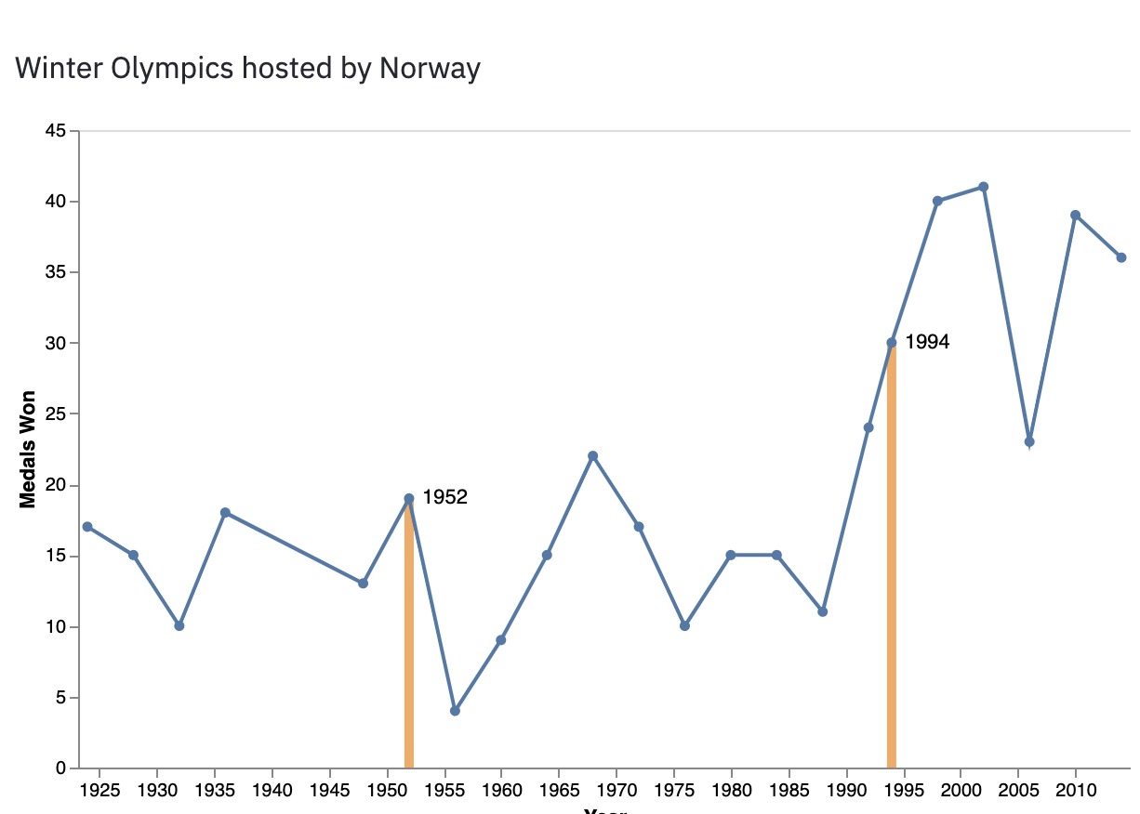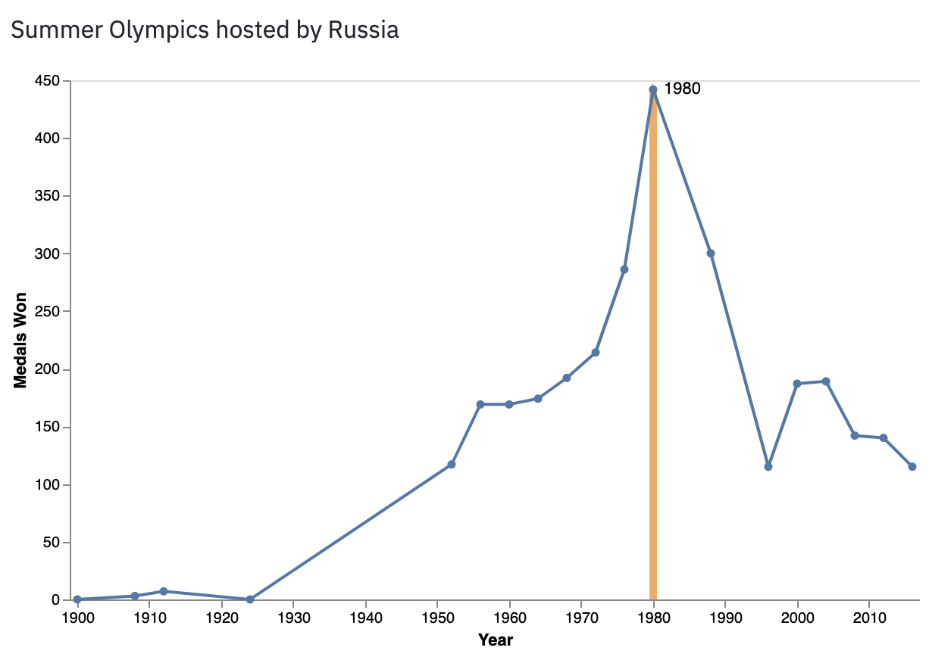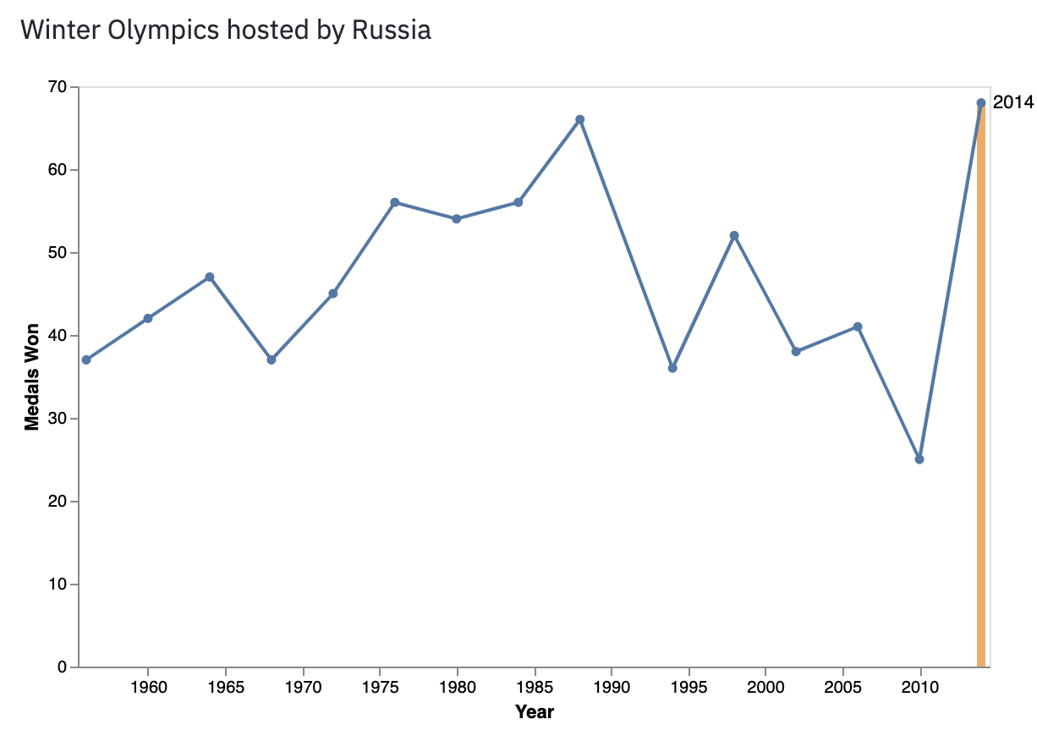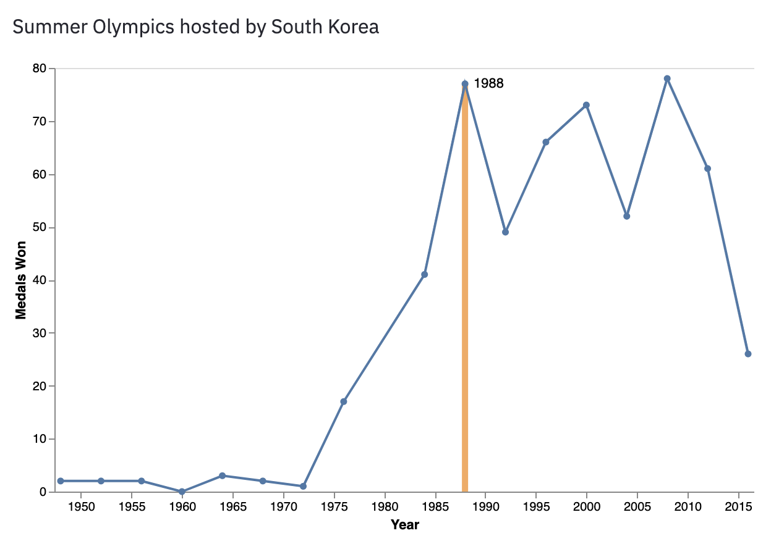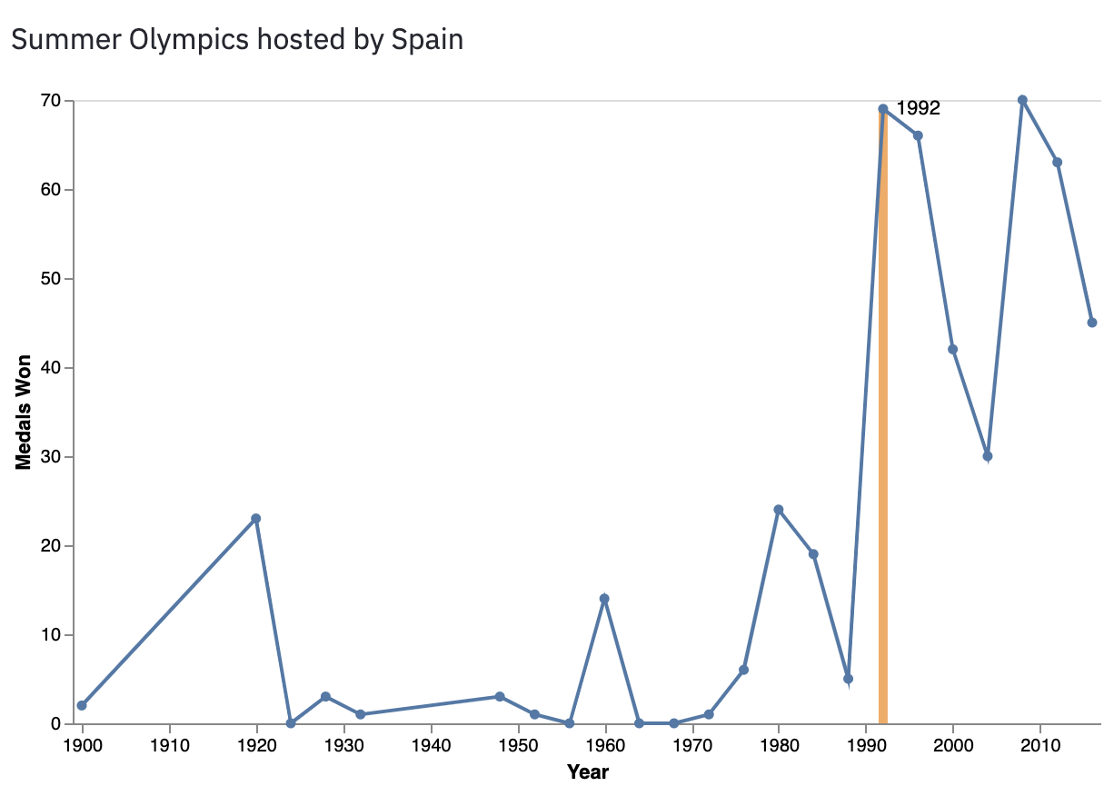

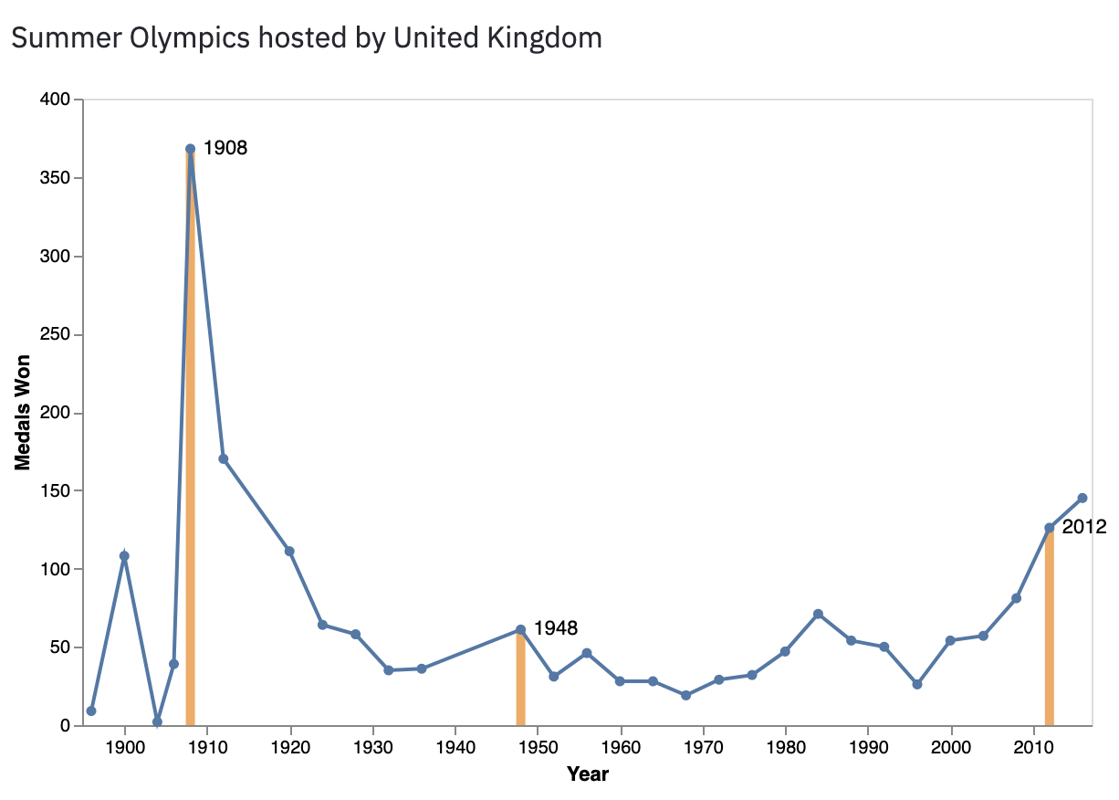

# Appendix II- Correlation Values for GDP and GDP Per Capita

## Correlation Scatter Plots

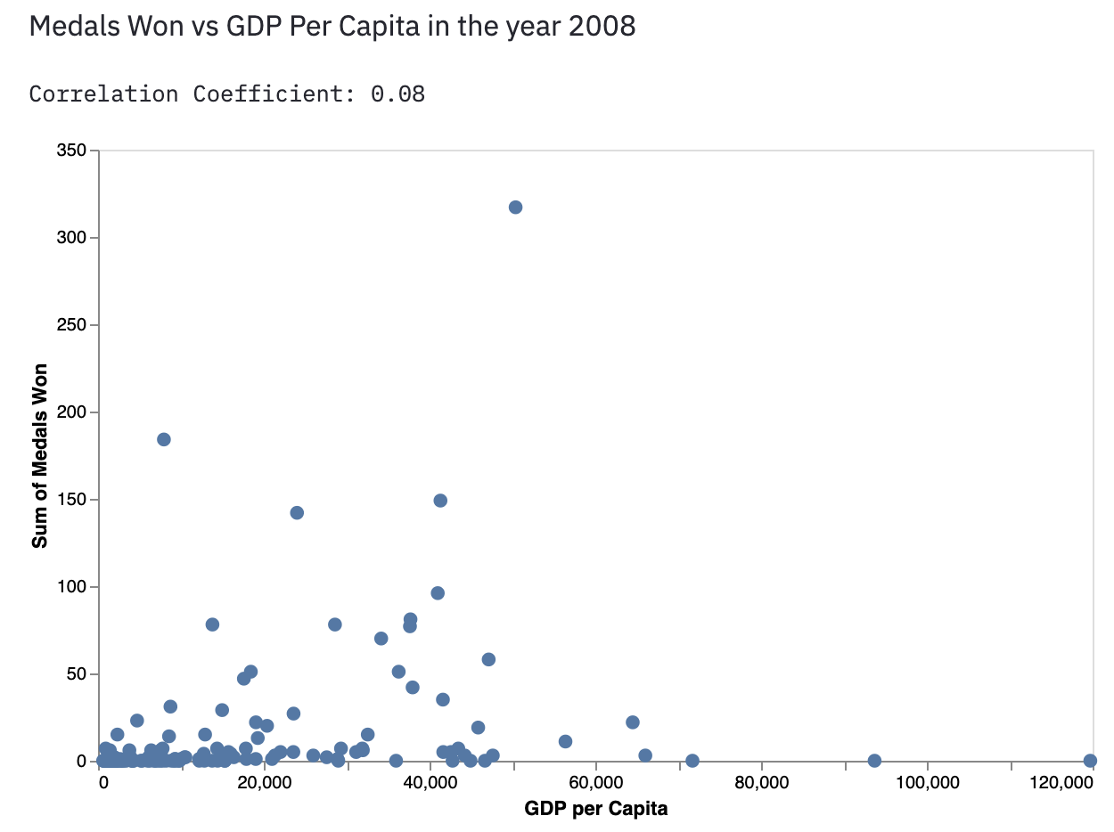

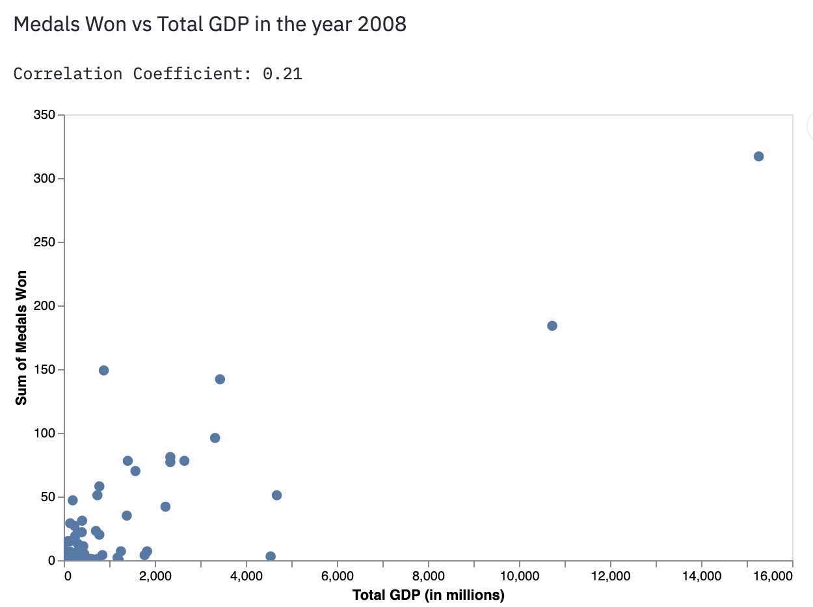

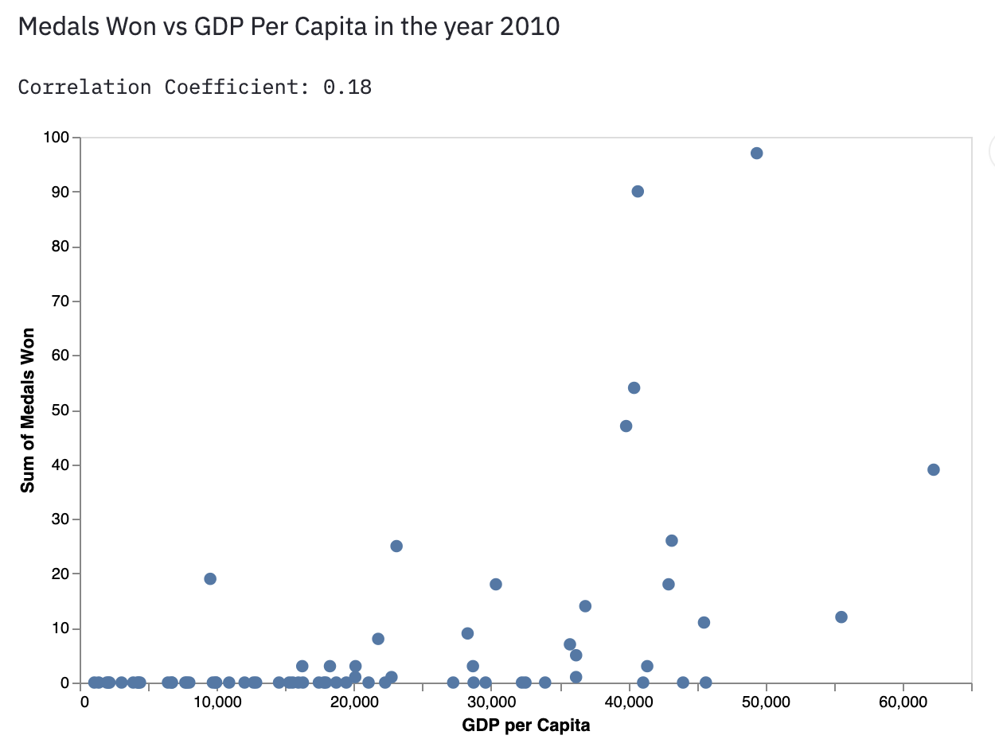

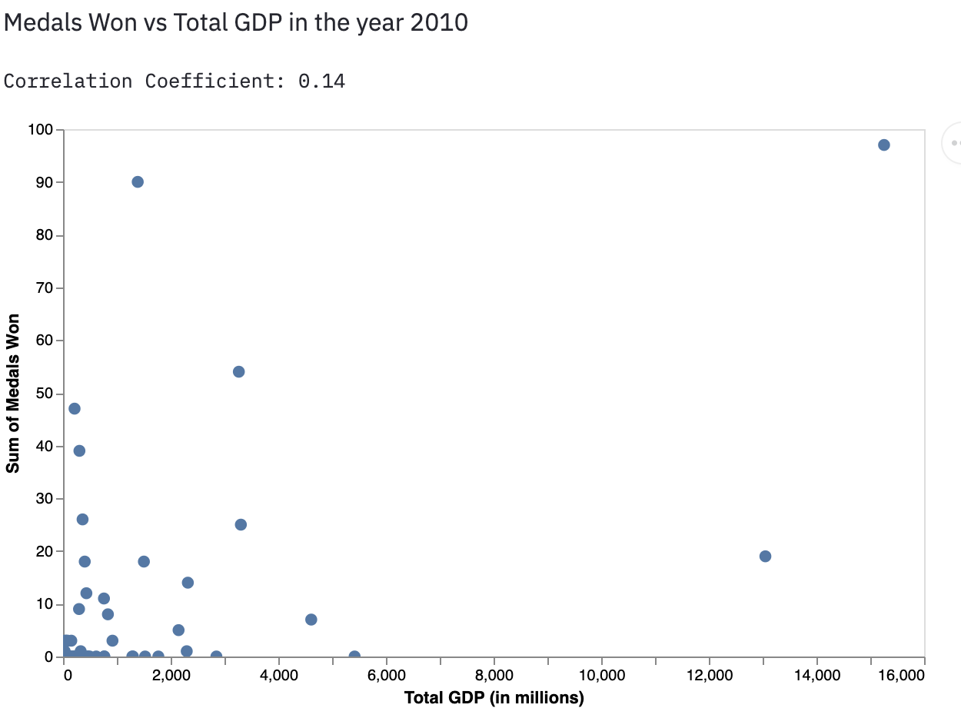

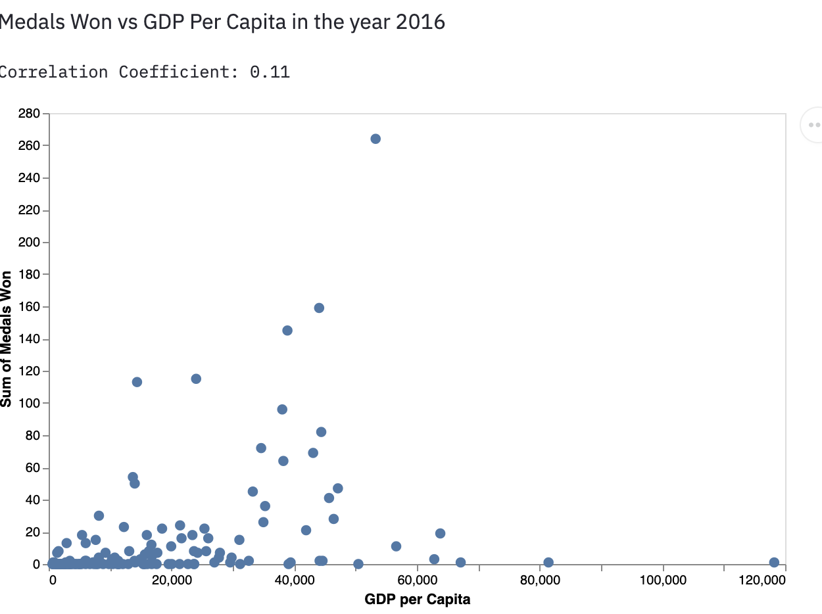

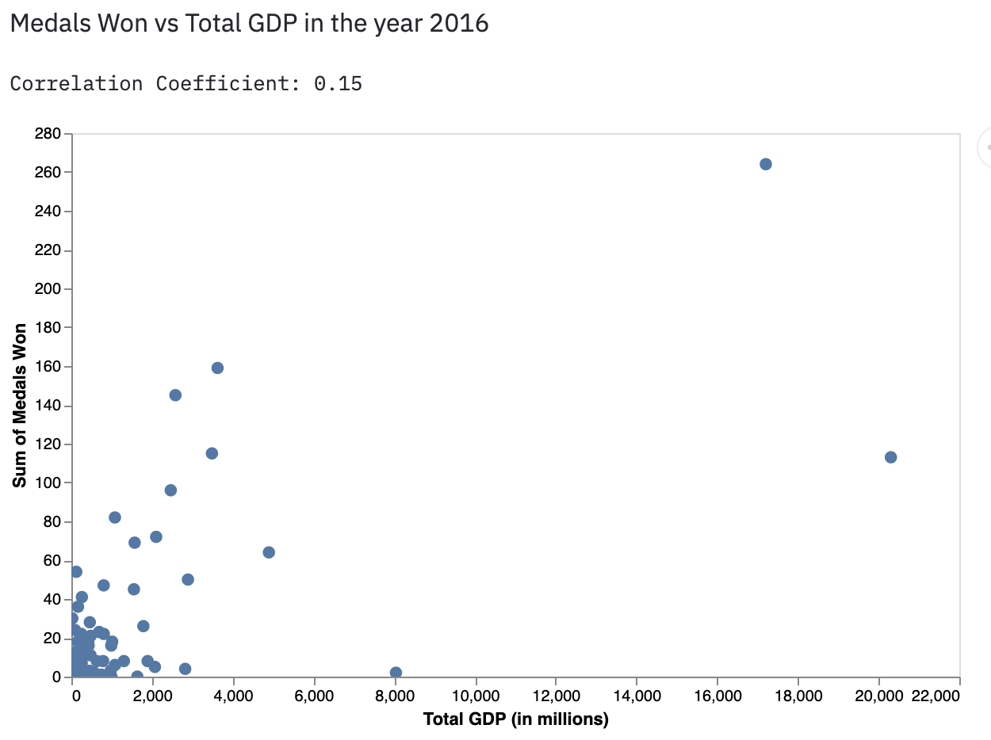

## Correlation Data- GDP, Population, GDP Per Capita

|  |  |  |  |  |
| --- | --- | --- | --- | --- |
|  | **Year** | **Corr_GDP** | **Corr_Popn** | **Corr_GDP_pc** |
| **0** | 1896-01-01 | 0.1482556396167299 | 0.12385713197190039 | 0.11846139970776402 |
| **1** | 1900-01-01 | 0.26792362626670096 | 0.09470385667315558 | 0.3791930555197616 |
| **2** | 1904-01-01 | 0.005948945339004744 | 0.0009640730958988231 | 0.013833059230800882 |
| **3** | 1906-01-01 | 0.08528332375323115 | 0.07091293373660627 | 0.12963199969332212 |
| **4** | 1908-01-01 | 0.11014020740686996 | 0.06039741946107625 | 0.13469856026136964 |
| **5** | 1912-01-01 | 0.05252786064952849 | -0.015065802797246284 | 0.17036173286164302 |
| **6** | 1920-01-01 | 0.08960793601237702 | 0.06760417347524574 | 0.07999295162784635 |
| **7** | 1924-01-01 | 0.19255664820589127 | 0.12906081414306 | 0.15016322756776943 |
| **8** | 1928-01-01 | 0.08460473455503692 | 0.12216495024341524 | 0.0285489250704508 |
| **9** | 1932-01-01 | 0.08020133898928913 | 0.10175890661576996 | 0.01989051603573178 |
| **10** | 1936-01-01 | 0.1306380763450608 | 0.07631182549721102 | 0.07669018458596673 |
| **11** | 1948-01-01 | 0.1848550784010514 | 0.10238947913501707 | 0.09429437491998845 |
| **12** | 1952-01-01 | 0.18324530218095667 | 0.14204614940841073 | 0.10291062679733474 |
| **13** | 1956-01-01 | 0.14656239670854 | 0.1277088343704316 | 0.07941785099346724 |
| **14** | 1960-01-01 | 0.22955101838398856 | 0.23269373589822728 | 0.058973595105263975 |
| **15** | 1964-01-01 | 0.25559800559685436 | 0.18953781105475576 | 0.1287639714573382 |
| **16** | 1968-01-01 | 0.2350936155005985 | 0.2661856057018205 | 0.11390383046890479 |
| **17** | 1972-01-01 | 0.24119973119381136 | 0.24728046773295392 | 0.04133802451901201 |
| **18** | 1976-01-01 | 0.22041639197787502 | 0.20645220460086833 | 0.009781487293699475 |
| **19** | 1980-01-01 | 0.4343201834795484 | 0.2124990729183301 | 0.004178597680168503 |
| **20** | 1984-01-01 | 0.32066815742634874 | 0.12731596845044488 | 0.09362372090949984 |
| **21** | 1988-01-01 | 0.20421549498506217 | 0.060476065774674036 | 0.06040559996927415 |
| **22** | 1992-01-01 | 0.16734526900634708 | 0.07789011726449438 | 0.054891175178935894 |
| **23** | 1996-01-01 | 0.14927735670188508 | 0.09048416261399049 | 0.06793423852021203 |
| **24** | 2000-01-01 | 0.1352328261569431 | 0.05201608006961378 | 0.080627604504598 |
| **25** | 2004-01-01 | 0.1730841890431268 | 0.051686559918290076 | 0.085146470103365 |
| **26** | 2008-01-01 | 0.20618625179687775 | 0.10345919613592047 | 0.0773985706617476 |
| **27** | 2012-01-01 | 0.17415596464888447 | 0.08858794147294878 | 0.1069147579840293 |
| **28** | 2016-01-01 | 0.15159696580085594 | 0.058637377863085476 | 0.10893468661545762 |

## Highest and Lowest GDPs

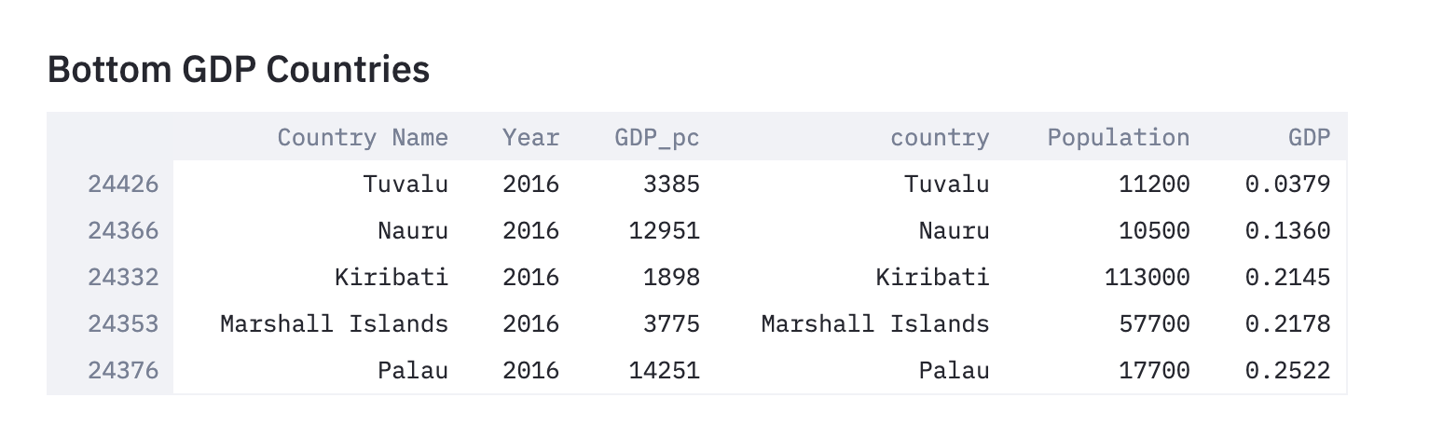

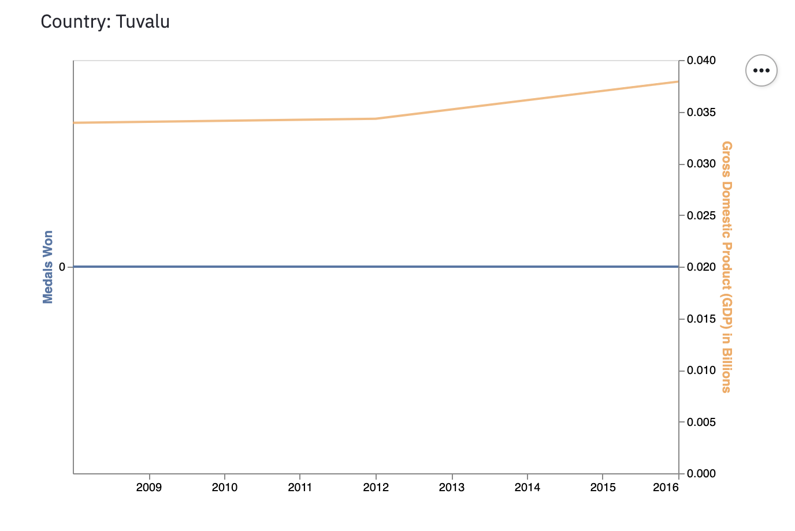

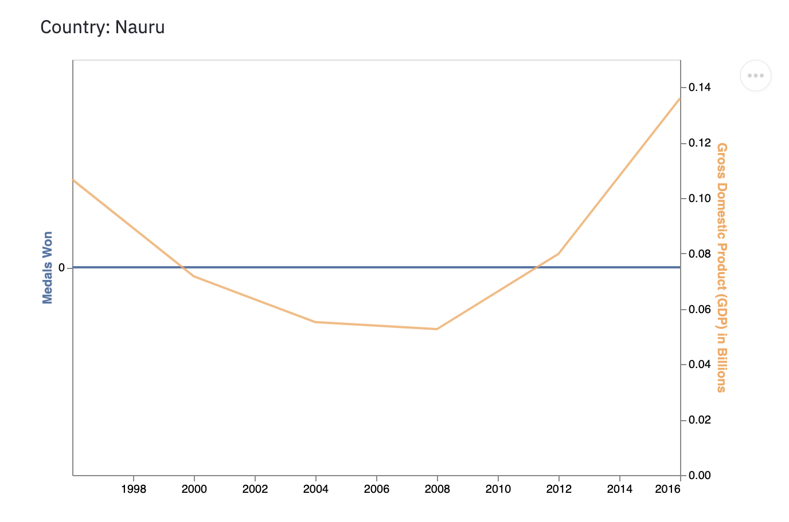

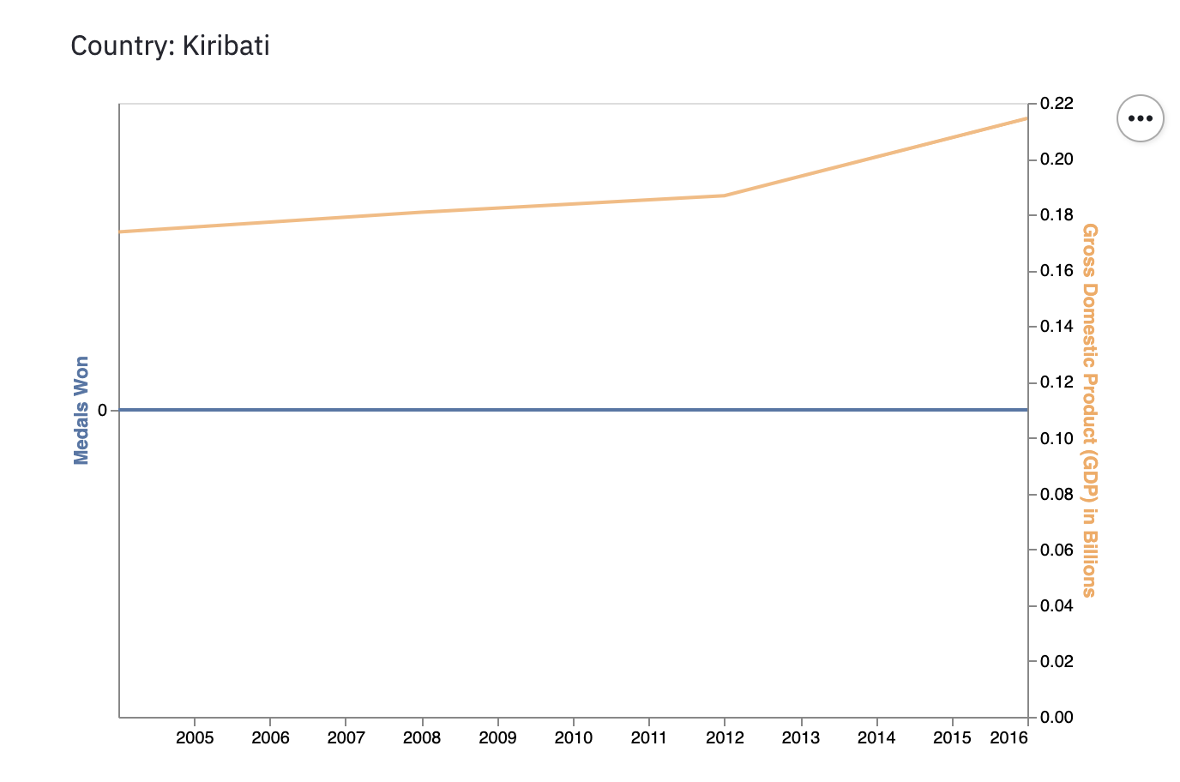

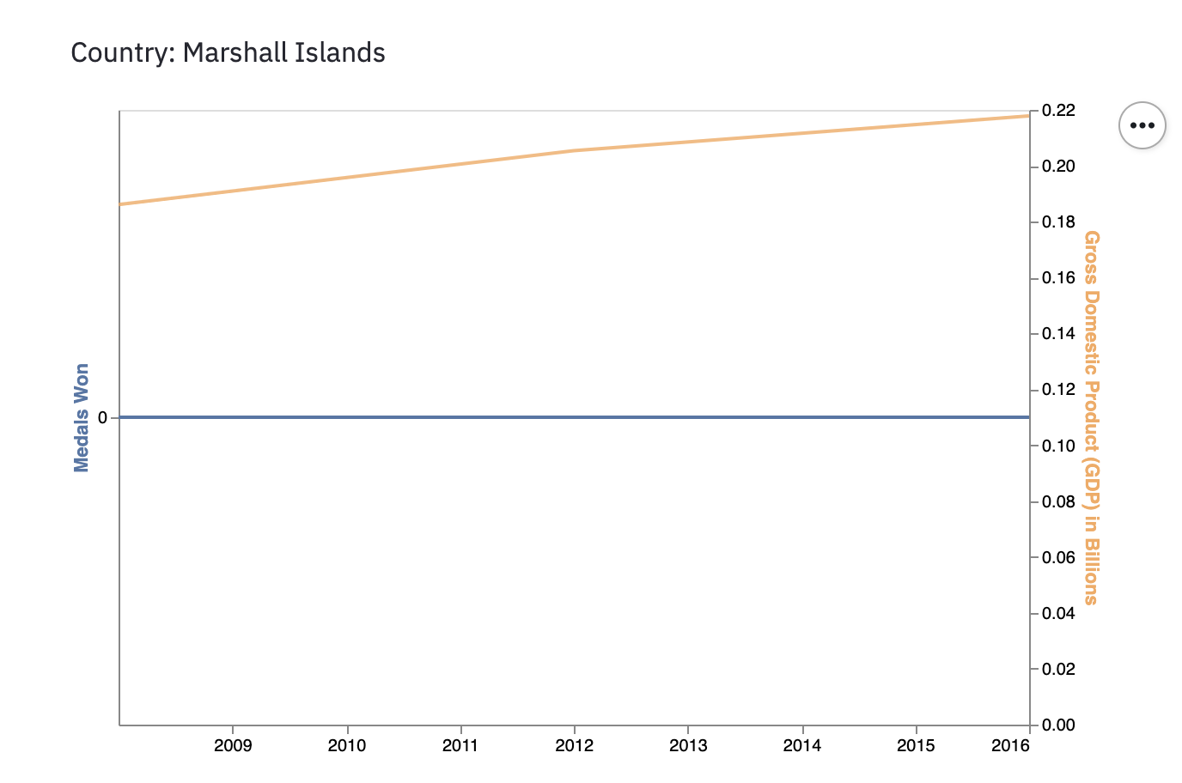

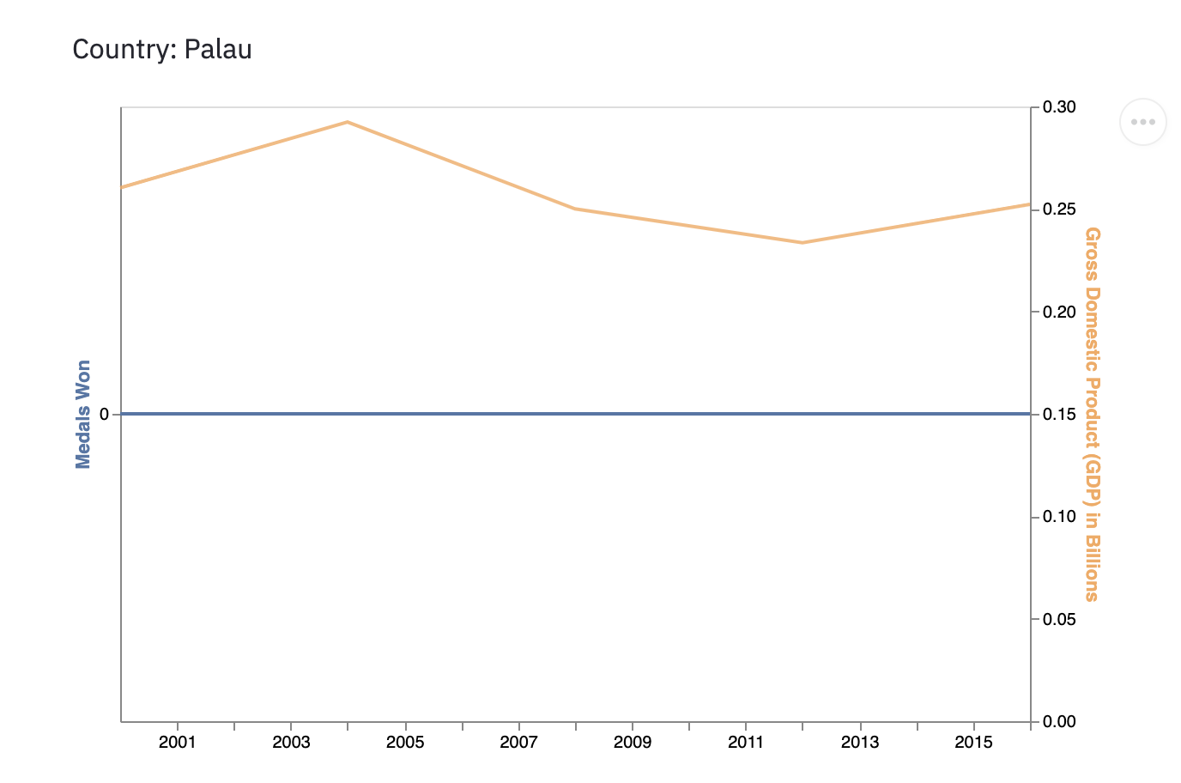

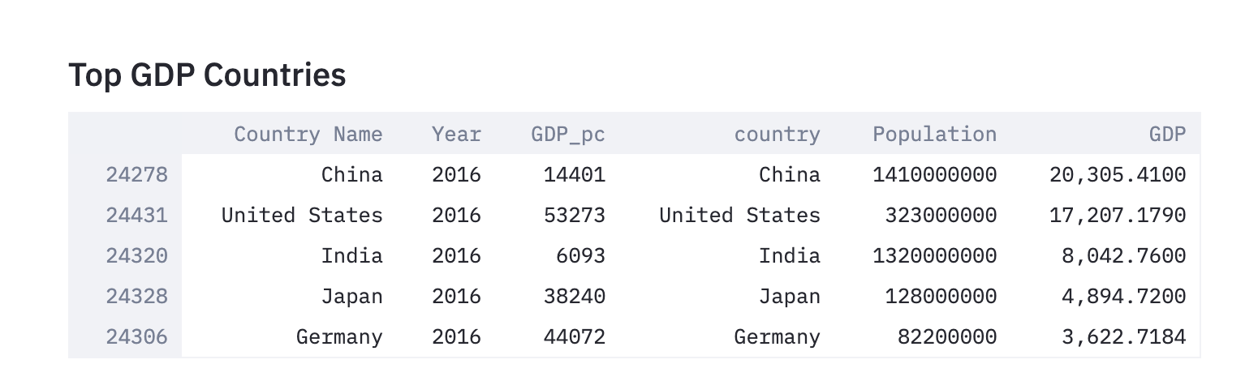

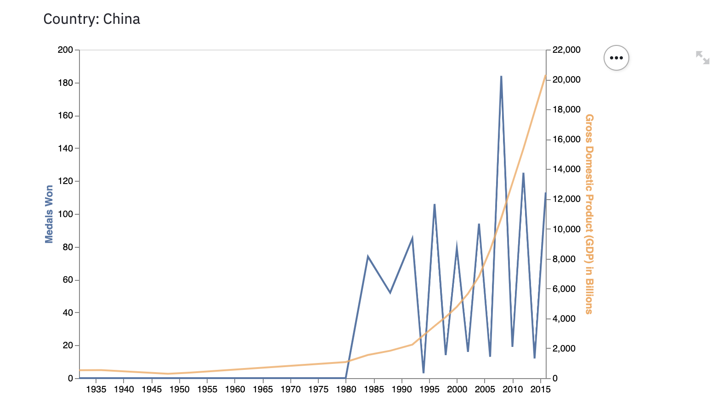

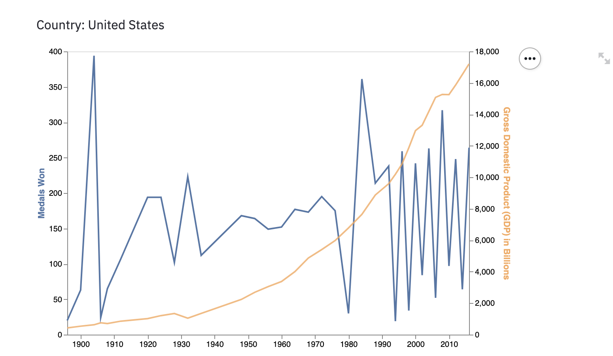

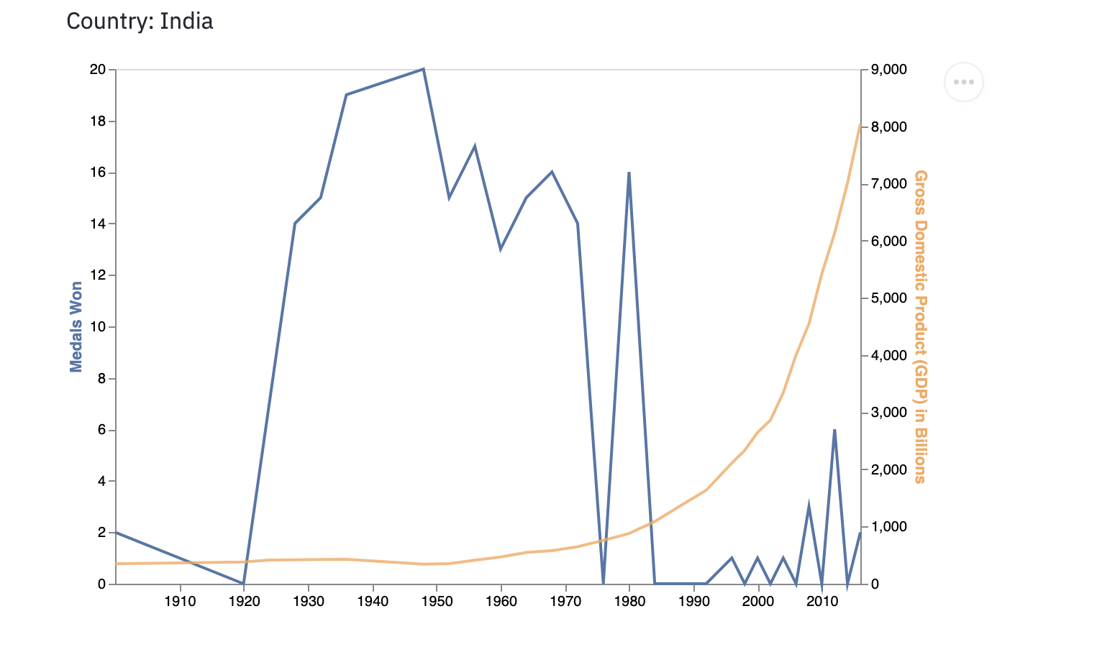

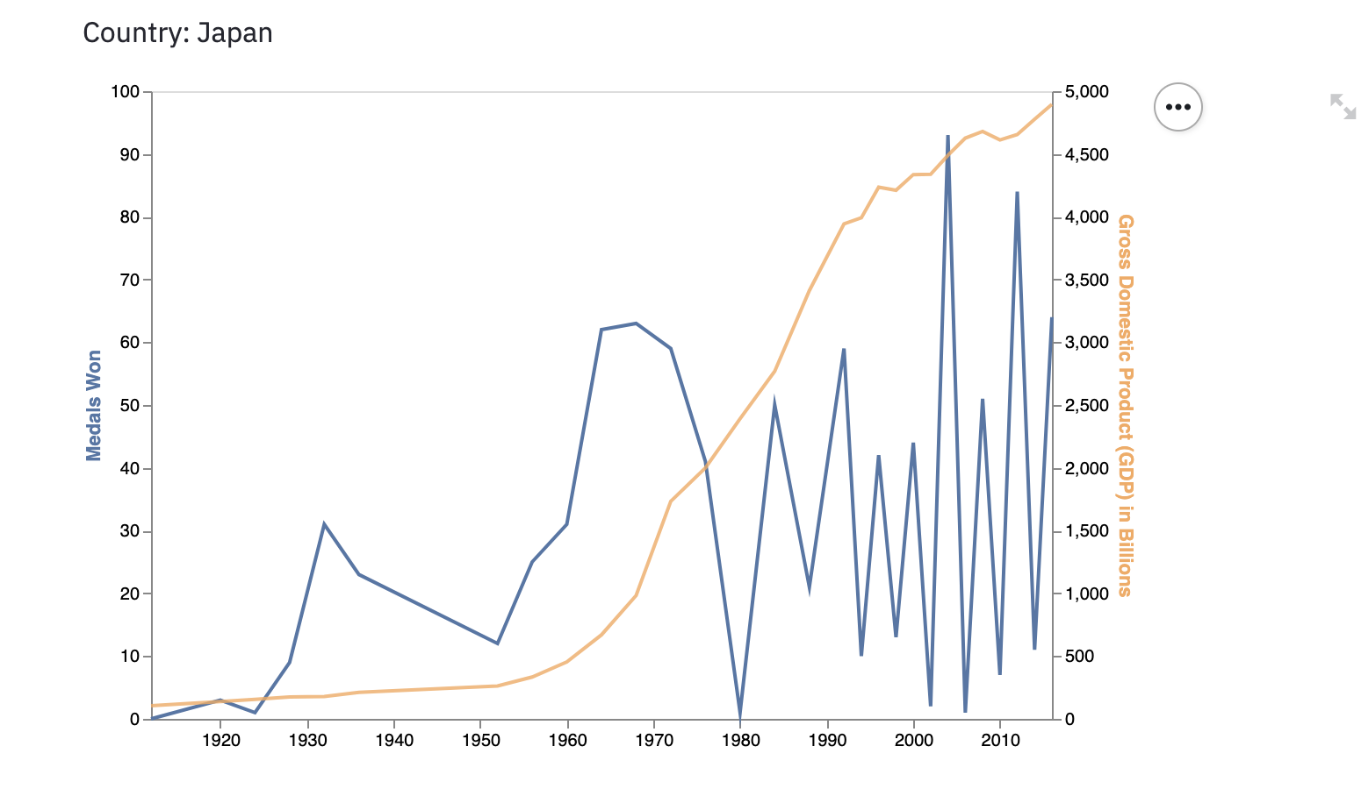

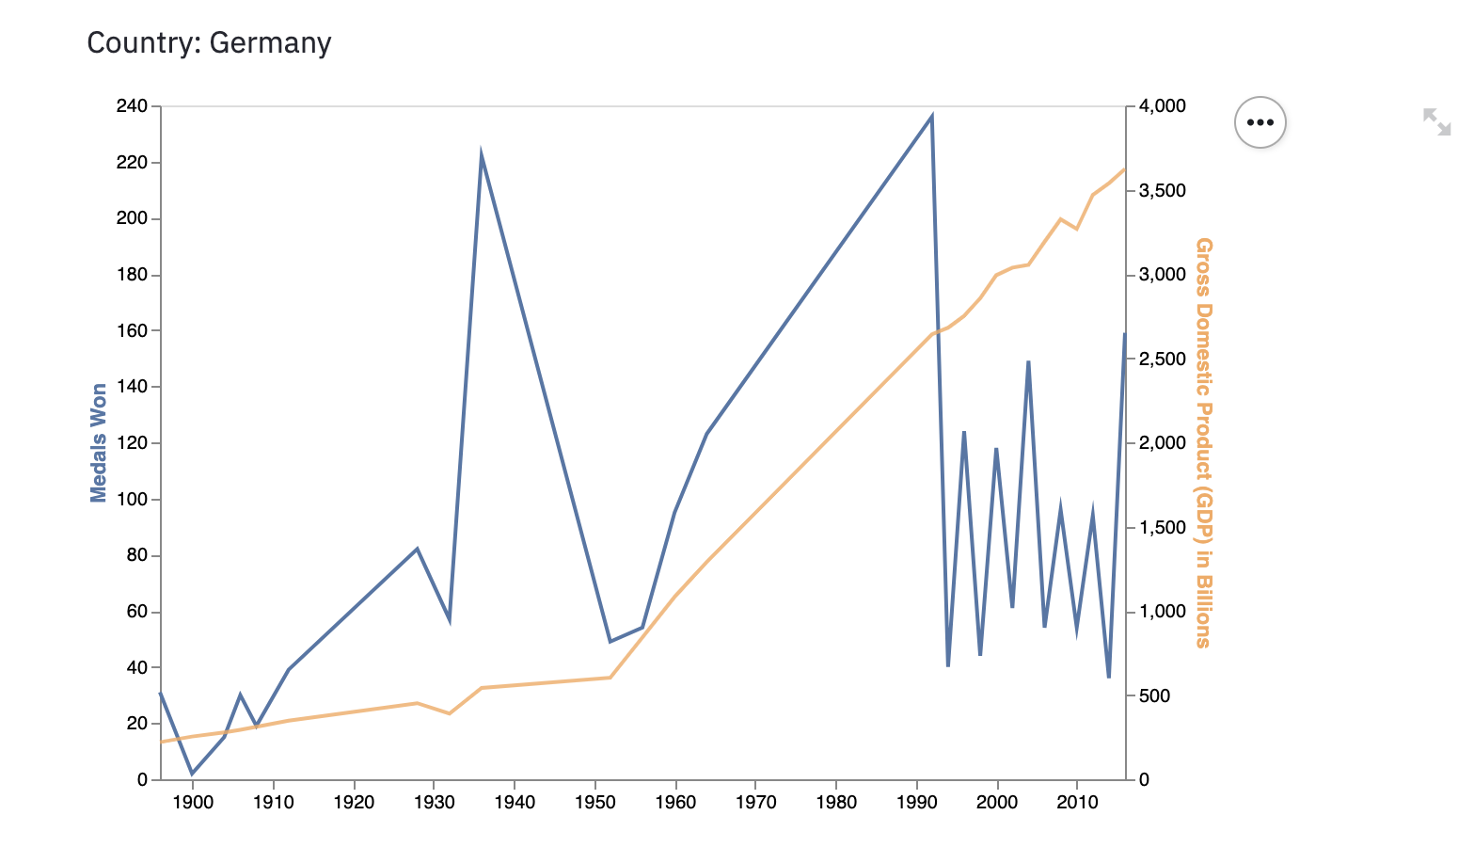

# Appendix III- Age range for all sports

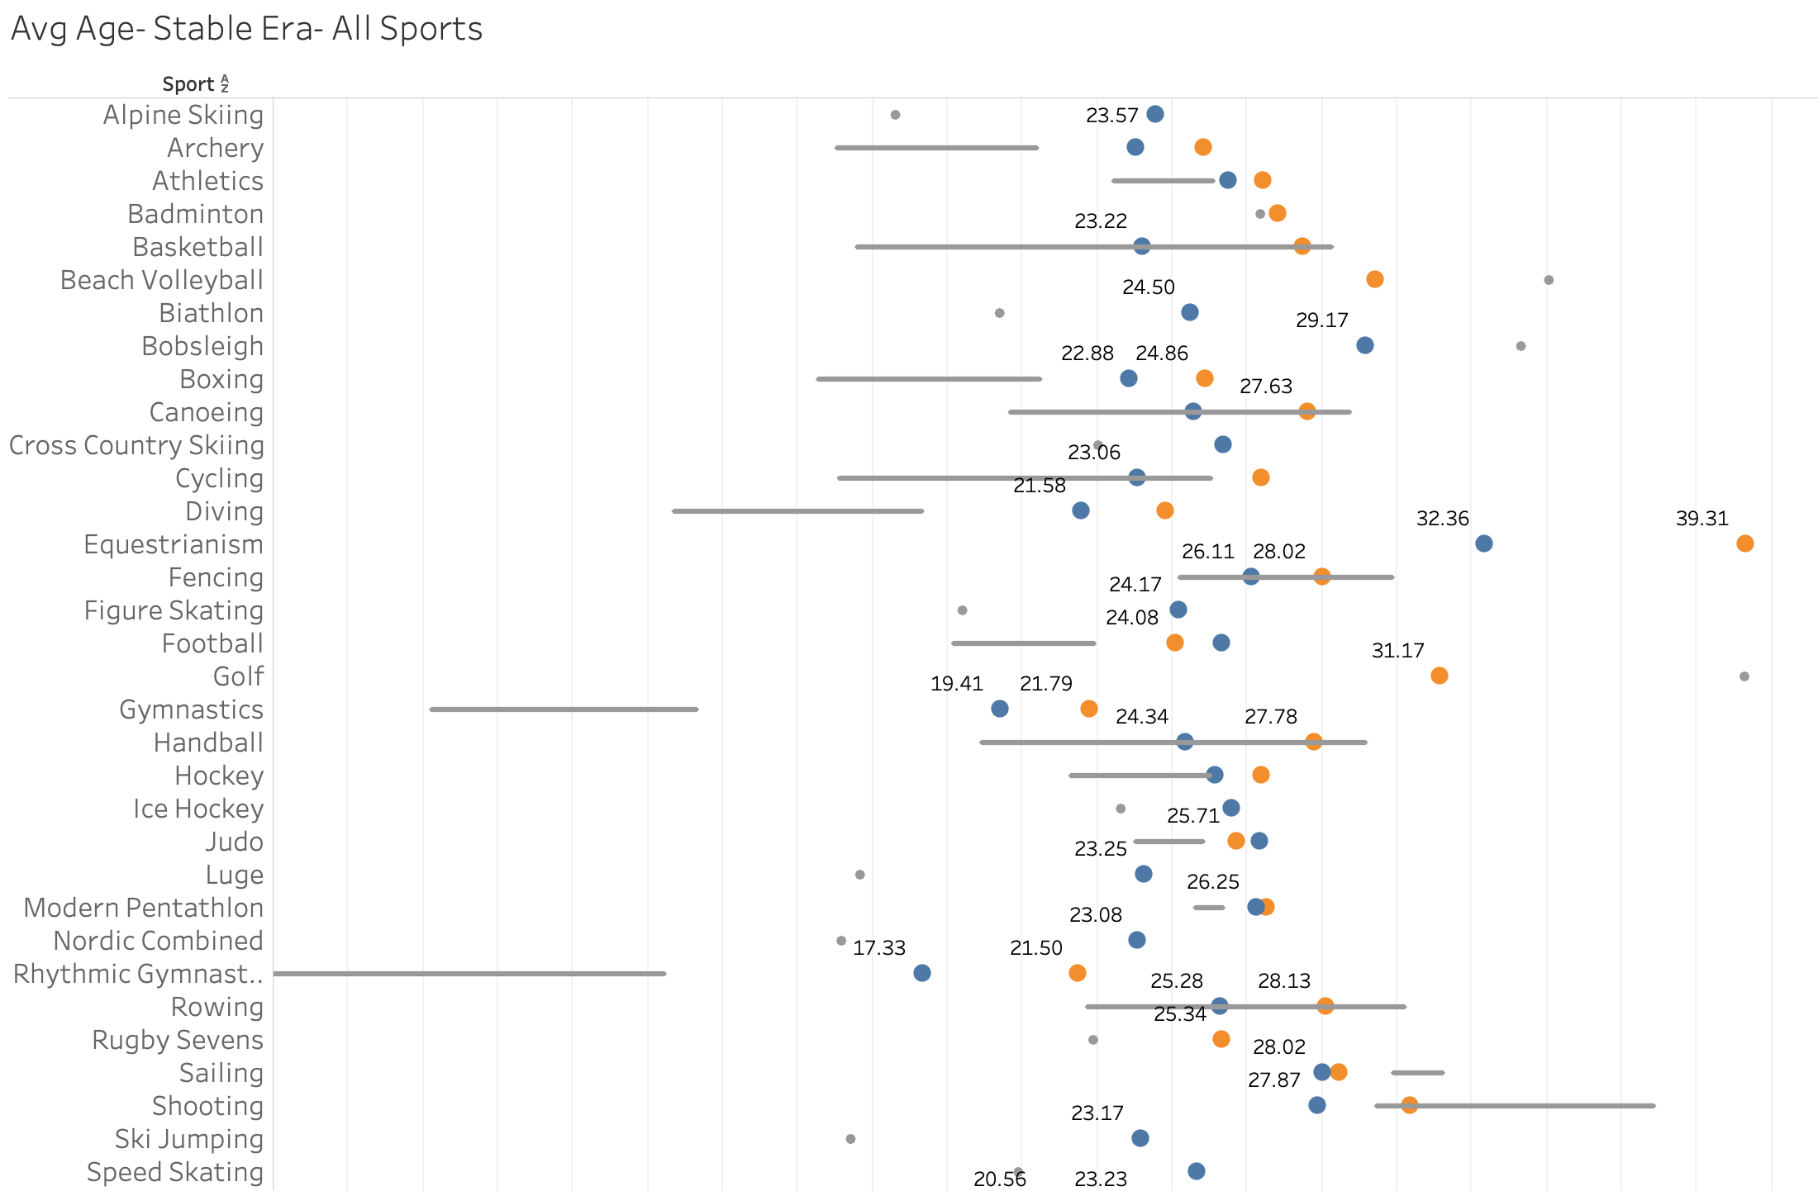

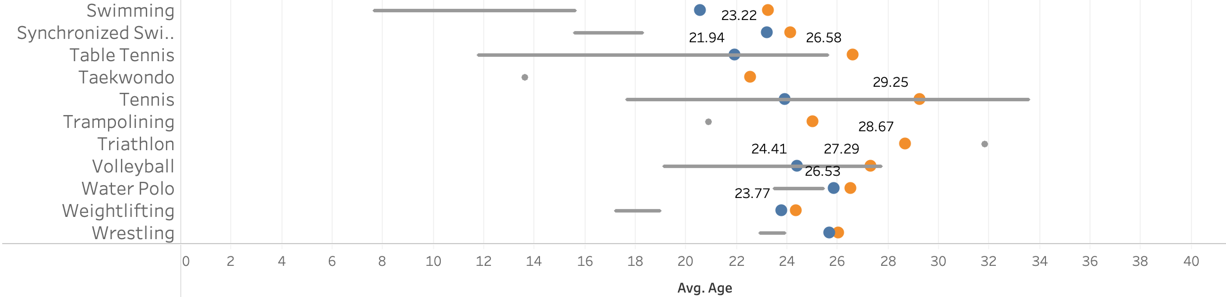

1. https://www.kaggle.com/heesoo37/120-years-of-olympic-history-athletes-and-results
2. <https://www.gapminder.org/data/documentation/gd001/>
3. https://gapm.io/d_popv6
4. https://www.olympic.org/